Student Enrollment & Course Management System (SECMS)

User Story:

The Student Enrollment & Course Management System (SECMS) is a complete Salesforce-based application created to simplify and automate the admission and academic activities of an educational institution. It allows admins, enrollment staff, and faculty to manage student information, available courses, enrollments, instructor allocations, approval workflows, payments, and reporting effectively in a single Salesforce system.

1.INTRODUCTION

1.1Project Overview:

The main goal of this project is to bring all student, course, and enrollment data into one Salesforce application for easy access, proper workflow, and accurate reporting. Enrollment officers can efficiently handle admissions, course registrations, and student communication, while instructors and admins get complete visibility of course assignments and academic progress. The system also supports automatic instructor assignment, task creation, data validations, and multi-level approvals for enrollments.

By using Salesforce Flows, Approval Processes, Validation Rules, Reports, and Dashboards, all activities from admission to course completion can be managed in a systematic way, while also tracking important metrics like total enrollments, revenue, student status, and pending approvals.
  - Purpose:

The main purpose of SECMS is to replace the manual and scattered enrollment process with a scalable, automated, and secure Salesforce solution which ensures:
- Accurate maintenance of student data
- Well-structured enrollment workflows
- Automated approval processes and data validations
- Clear and transparent reporting and monitoring
2 .IDEATION PHASE

2.1 Problem Statement (Customer Problem Statement Template)

PS | I am (Customer) | I'm trying to | But | Because | Which makes me feel
PS-1 | Enrollment Officer | handle student enrollments in an efficient way | enrollment information is scattered everywhere | the current processes are manual and not connected | frustrated and more likely to make errors
PS-2 | Administrator | monitor enrollments and revenue performance | reports and insights are coming very late | there is no centralized database | unsure and not confident while making decisions

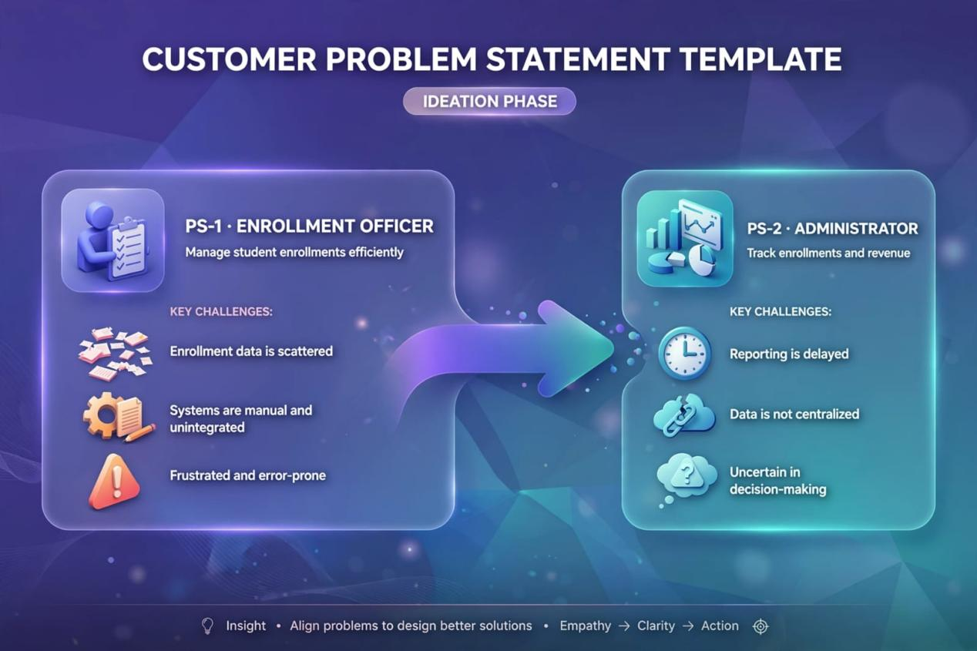

2.2 Empathy Map Canvas

User Persona: Enrollment Officer

- Think & Feel: Stressed about double entries and loss in revenue
- Hear: Students complaining and managers questioning delays
- See: Numerous Excel sheets and inbox full of emails
- Say & Do: Cross-checks details repeatedly and follows up in person
- Pain: Repetitive records, slow approval process
- Gain: Auto-verification, centralized dashboard, speedy enrollment

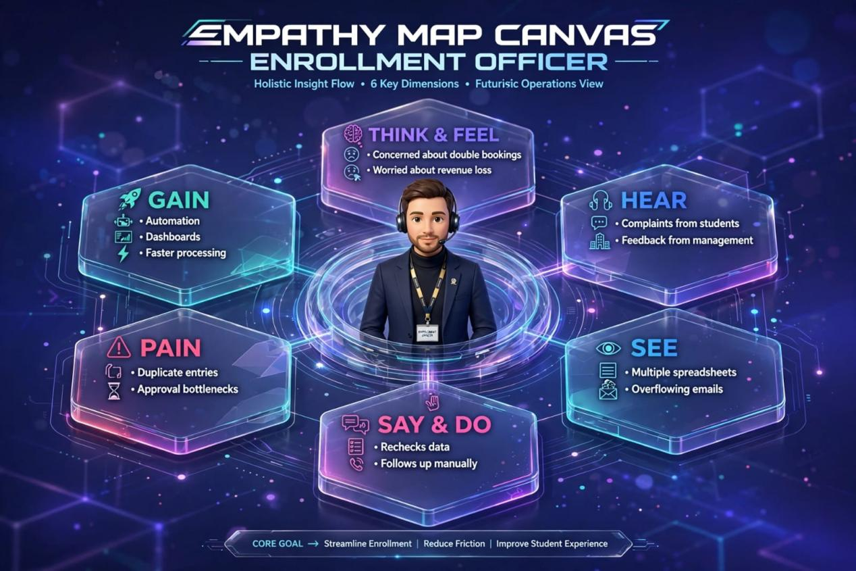

2.3 Brainstorming & Idea Prioritization
Step 1 – Ideas Generated
- Excel-based automation
- Independent enrollment web portal
- ERP system linkage
- Salesforce-powered enrollment platform
Step 2 – Categorization
- Basic manual approach
- Partially automated approach
- Completely automated cloud-based approach
Step 3 – Final Selection
Salesforce-based SECMS was finalized as it offers maximum feasibility with maximum impact.

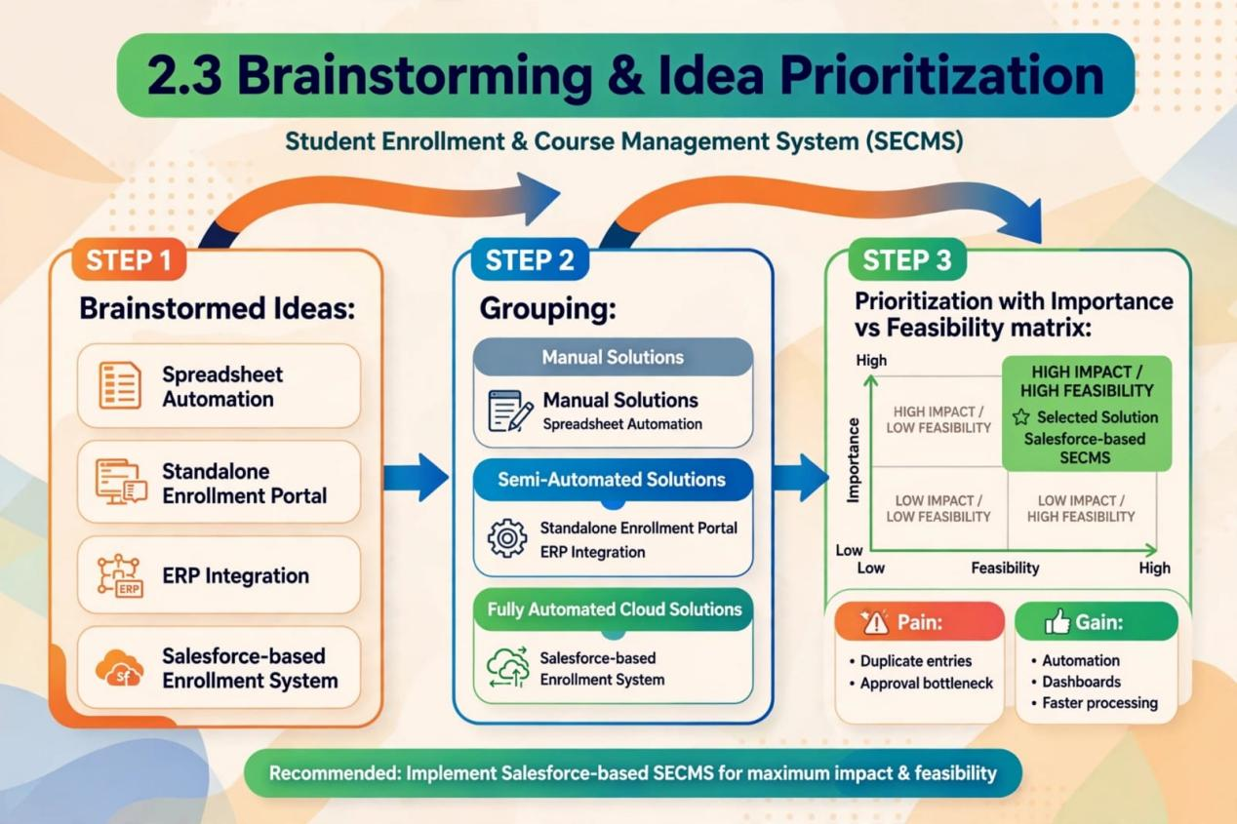
3.REQUIREMENT ANALYSIS PHASE

3.1 Customer Journey Map

Stages covered:

- Awareness & Registration
- Course Selection
- Enrollment Request
- Fee Payment
- Approval
- Instructor Assignment
- Reporting & Completion

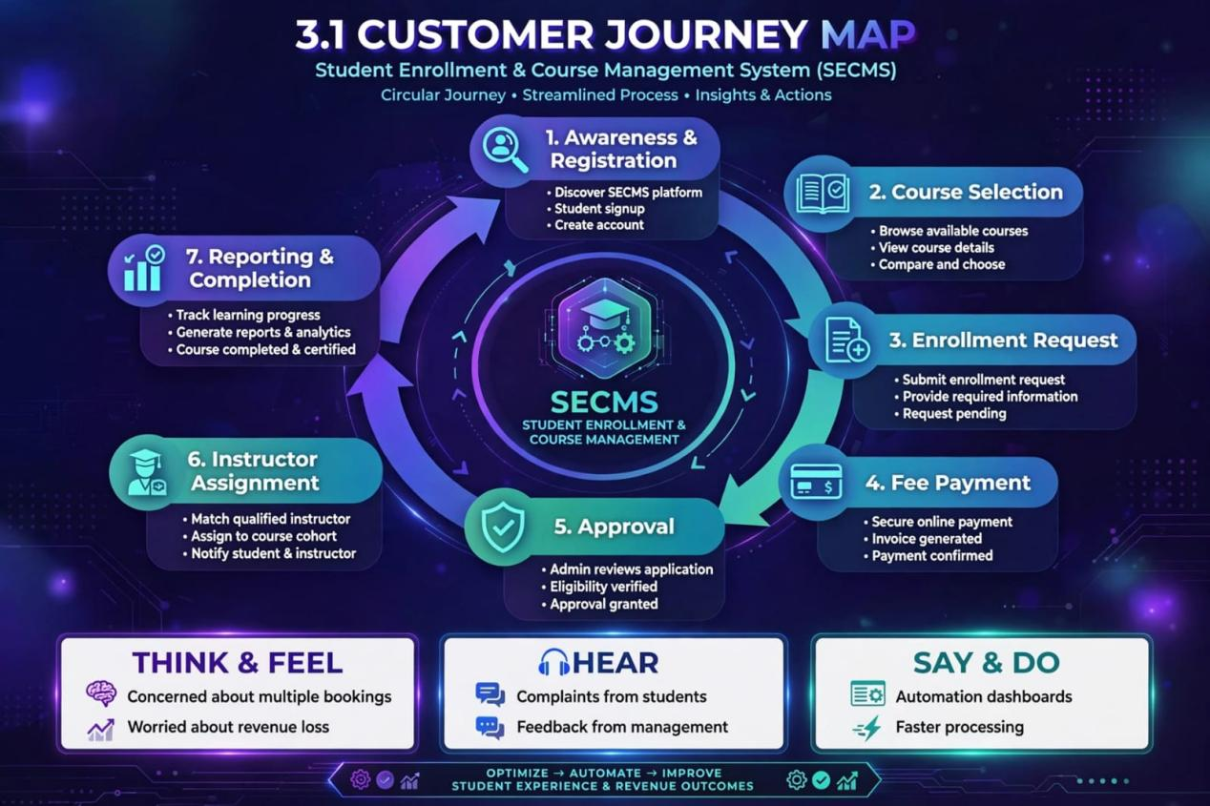

3.2 Solution Requirements

3.2.1 Functional Requirements
The functional requirements define the core features and operations that the SECMS platform must provide.
FR No | Epic / Module | Description
FR-1 | Student Management | The system shall allow creation, updating, viewing and deletion of student profiles and maintain complete student records securely.
FR-2 | Course Management | The system shall enable admin to create, edit, manage and publish courses with details like duration, capacity and fees.
FR-3 | Enrollment Processing | The system shall handle enrollment lifecycle - students can request enrollment, admin can approve or reject requests with notifications.
FR-4 | Instructor Allocation | The system shall automatically assign suitable instructors to approved enrollments based on availability and expertise.
FR-5 | Reporting & Analytics | The system shall generate dashboards, enrollment reports, revenue reports and performance analytics for management decisions.

NFR-1: Usability
The platform must offer a clean, intuitive and user-friendly interface for all user roles including students, instructors, enrollment officers and administrators. The design should minimize learning curve and allow users to complete tasks with minimal clicks. The navigation will be structured with role-based tabs, dashboards and simplified forms to reduce errors and improve efficiency.

Examples:
- Simplified student registration form
- Single-click approval for enrollments
- Personalized dashboards based on user roles.

NFR-2: Security
The system must guarantee confidentiality and integrity of all student and academic data through robust authentication and authorization mechanisms. Access to sensitive information such as personal details, fee records and enrollment history shall be strictly restricted to authorized personnel only.

Examples:
- Only administrators can edit course master data
- Instructors can view only their assigned students
- Students are restricted from accessing other students' data.

NFR-3: Reliability
The SECMS shall function consistently without errors during critical operations like enrollment, approval and report generation. All automation workflows must execute accurately to prevent duplicate entries or data inconsistency.

Examples:
- Prevention of duplicate course enrollment
- Real-time status update after approval action
- Accurate and consistent reporting output.

NFR-4: Performance
The system must deliver fast response time for all transactions to ensure seamless user experience, particularly during peak admission season. Search, filter and dashboard loading should be optimized for speed.

Examples:
- Instant dashboard loading
- Rapid student record search
- Lag-free bulk data upload.

NFR-5: Scalability
The solution should be designed to accommodate future growth in terms of number of students, courses, departments and concurrent users without impacting performance. It should support easy addition of new features and modules.
Examples:
- Adding new departments without system redesign
- Handling year-on-year increase in admissions
- Future extension to mobile app and web portal.

NFR-6: Availability
The system shall remain accessible continuously during institutional working hours and ensure minimal downtime. As a cloud-based solution, it must provide high availability and data backup for academic continuity.
Examples:
- 24/7 cloud availability
- Stable performance during peak enrollment periods
- Automated backup and recovery of records.

3.3 Data Flow Diagram (DFD) - Overview

The DFD illustrates how data moves within the SECMS:

- User provides student and enrollment related information as input.
- System validates the input data and stores it securely in database.
- Approval workflow routes the data to respective authorities for verification.
- Processed data is used to generate analytical reports and dashboards.

In summary, the system accepts enrollment requests, validates and stores records, executes approval routing, automatically assigns instructors and finally produces reports for decision making.
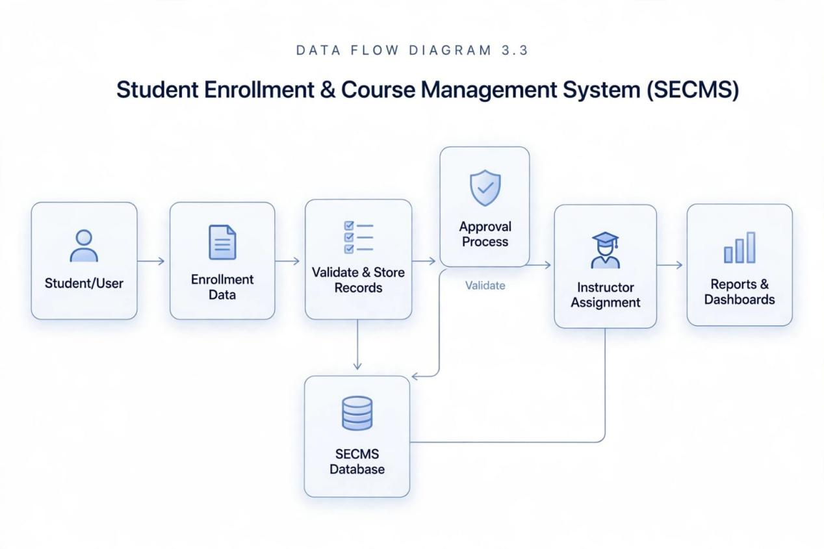3.4 Technology Stack

The Student Enrollment & Course Management System is entirely built on the Salesforce Platform, ensuring scalability, security and rapid development. The architecture is divided into layered components as follows:

Layer / Module | Technology Used | Purpose
Presentation Layer | Salesforce Lightning | Provides responsive, role-based user interface for all users
Business Logic Layer | Salesforce Flows | Handles automation of enrollment and assignment workflows
Automation Layer | Validation Rules, Approval Processes | Ensures data accuracy and controlled approval routing
Analytics Layer | Reports & Dashboards | Provides real-time insights and enrollment analytics
Data Layer | Salesforce objects | Stores student,course and enrollment records securely

4. PROJECT DESIGN PHASE
4.1 Problem-Solution Fit
Problem:
In many colleges, the student enrollment process is done manually. The data is kept in different places, which causes errors, delays, and no proper tracking.

Solution:
SECMS solves this problem. It brings everything into one system using Salesforce.
- It automatically checks the student data when they apply.
- It sends the application for quick approval.
- It assigns the instructor automatically after approval.
- It shows all reports and data in real-time dashboards.
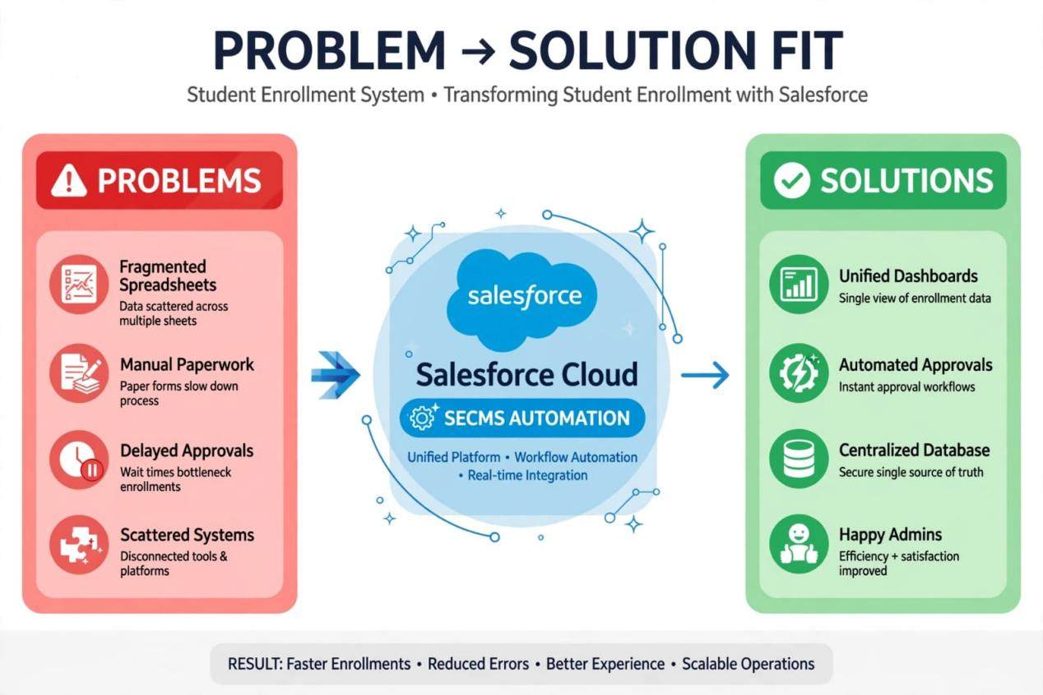
4.2 Proposed Solution

Functional Requirements
Parameter | Description
Problem Statement | Inefficient handling of manual student enrollment processes leading to operational bottlenecks
Proposed Solution | A comprehensive cloud-native solution - SECMS developed on Salesforce Platform
Novelty Aspect | Achieves complete end-to-end process automation with zero manual intervention
Social Impact | Significantly enhances student experience through streamlined and transparent enrollment
Revenue Model | Sustainable institutional-level deployment and licensing framework
Scalability Potential | Architected to support multi-departmental integration and cross-functional operations

4.3 Solution Architecture

The proposed system architecture is conceptualized as a multi-tiered, cohesive ecosystem that seamlessly integrates diverse Salesforce-native components. The core infrastructure encompasses custom Salesforce Objects for robust data modeling, declarative automation through Salesforce Flows, structured Approval Processes for governance, dynamic Reports and Dashboards for actionable intelligence, and multi-layered security frameworks to ensure data integrity and role-based access control. This interwoven architecture guarantees high cohesion, low coupling and enterprise-grade scalability.

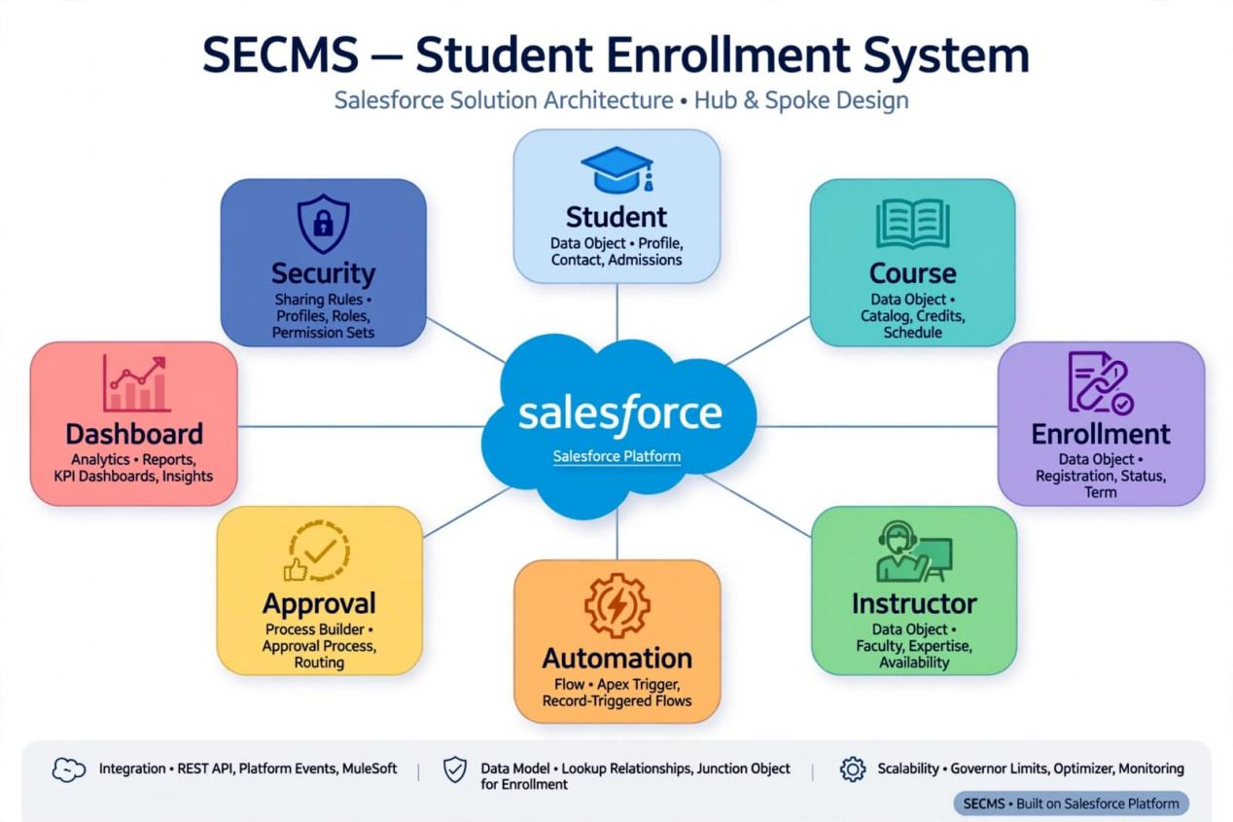

5. PROJECT PLANNING & SCHEDULING
5.1 Project Planning

- Project execution is orchestrated using Agile Scrum Framework.
- The comprehensive requirements are systematically deconstructed into Epics → User Stories → Story Points to facilitate incremental Sprint-based delivery.
- Velocity metrics are meticulously employed for precise estimation and forecasting.

Product Backlog, Sprint Schedule, and Estimation (4 Marks)
Use the below template to create product backlog and sprint schedule

Sprint | Functional Requirement (Epic) | User Story No | User Story / Task - NEW | Points | Priority | Team
Sprint-1 | Project Initialization | USN-1 | As a DevOps, I want to setup GitHub & CI/CD pipeline so that code deployment is automated | 2 | High | Member1
Sprint-1 | UI/UX Design | USN-2 | As a designer, I want to design wireframes for student portal so that UI is user-friendly | 3 | High | Member2
Sprint-2 | Authentication | USN-3 | As a user, I want OAuth & SSO login so that secure access is ensured | 5 | High | Member3
Sprint-2 | Student Onboarding | USN-4 | As an admin, I want QR code based Student ID generation so that identity verification is quick | 5 | High | Member4
Sprint-2 | Fee Management | USN-5 | As a student, I want Razorpay integration for fee payment so that online transactions are seamless | 8 | High | Member 1
Sprint-3 | AI Features | USN-6 | As a student, I want AI chatbot for enrollment queries so that 24/7 support is available | 8 | Medium | Member2
Sprint-3 | Attendance | USN-7 | As a faculty, I want biometric attendance tracking so that proxy is eliminated | 5 | High | Member 4
Sprint-3 | Certificate | USN-8 | As a system, I want auto-generation of course completion certificates so that manual work is reduced | 3 | High | Member 3
Sprint-4 | Notification | USN-9 | As a student, I want WhatsApp/SMS alerts for deadlines so that I don't miss submissions | 5 | High | Member1
Sprint-4 | Analytics | USN-10 | As a principal, I want predictive analytics for dropout students so that intervention is possible | 8 | Medium | Member 2
Sprint-5 | Mobile App | USN-11 | As a user, I want Flutter mobile app for SECMS so that access is possible on mobile | 8 | High | Member 3
Sprint-5 | Feedback | USN-12 | As an admin, I want student feedback & rating system so that teaching quality improves | 3 | Medium | Member4
Sprint-6 | Deployment | USN-13 | As a DevOps, I want cloud deployment & load testing so that system handles 10k users | 5 | High | Member  1

Project Tracker,Velocity&Burden Chart:(4 Marks)
Sprint | Total Story Points | Duration | Sprint Start Date | Sprint End Date  (Planned) | Story Points Completed  (as on planned End Date) | Sprint Release Date (Actual)
Sprint-1 | 20 | 6 Days | 29 Oct 2026 | 29 Oct 2026 | 20 | 29 Oct 2026
Sprint-2 | 20 | 6 Days | 05 Nov 2026 | 05 Nov 2026
Sprint-3 | 20 | 6 Days | 12 Nov 2026 | 12 Nov 2026
Sprint-4 | 20 | 6 Days | 19 Nov 2026 | 19 Nov 2026

6.Project Development Phase:

Project Flow:

Milestone 1: Salesforce Developer Account Creation
Milestone 2: Custom Object Creation (Student, Course, Enrollment, Instructor)
Milestone 3: Tabs Creation
Milestone 4: Lightning App Creation
Milestone 5: Fields Creation
Milestone 6: Create Relationships
Milestone 7: Page Layout Customization
Milestone 8: Validation Rules
Milestone 9: Flows (Automation)
Milestone 10: Approval Process
Milestone 11: Reports
Milestone 12: Dashboards
Milestone 13: Security Setup
Milestone 14: Conclusion

What You'll Learn:

1. How to do real Salesforce project from start to end
2. How to create custom objects and link them together
3. How to make page layouts and record types
4. How to write validation rules for data correctness
5. How to build Flows for automation
6. How to create approval process for enrollment
7. How to make reports and dashboards
8. How to setup security using profiles and permission sets
9. How to test the full application end to end

Milestone 1-Salesforce :
Introduction:

New to the Salesforce ecosystem? Uncertain about its core functionalities and implementation methodology? Struggling to identify the optimal starting point for your CRM learning journey? If yes, this module is precisely designed for you.

Welcome to Salesforce - a revolutionary cloud computing platform! It is a game-changing Customer Success Platform engineered to accelerate sales performance and enhance business productivity through its comprehensive suite of features.

What is Salesforce?

Salesforce is a cloud software where you can manage your customers. You can do selling, customer service, marketing, and store all data in one place. Before Salesforce, all customer details were in different places like Excel and emails. Salesforce keeps everything together.
Prior to Salesforce, business data was scattered across emails, spreadsheets, and sticky notes. Salesforce brings everything under one integrated platform.

Reference Video: https://youtu.be/r9EX3lGde5k

How to Create Developer Account?

- Go to this link: https://developer.salesforce.com/signup
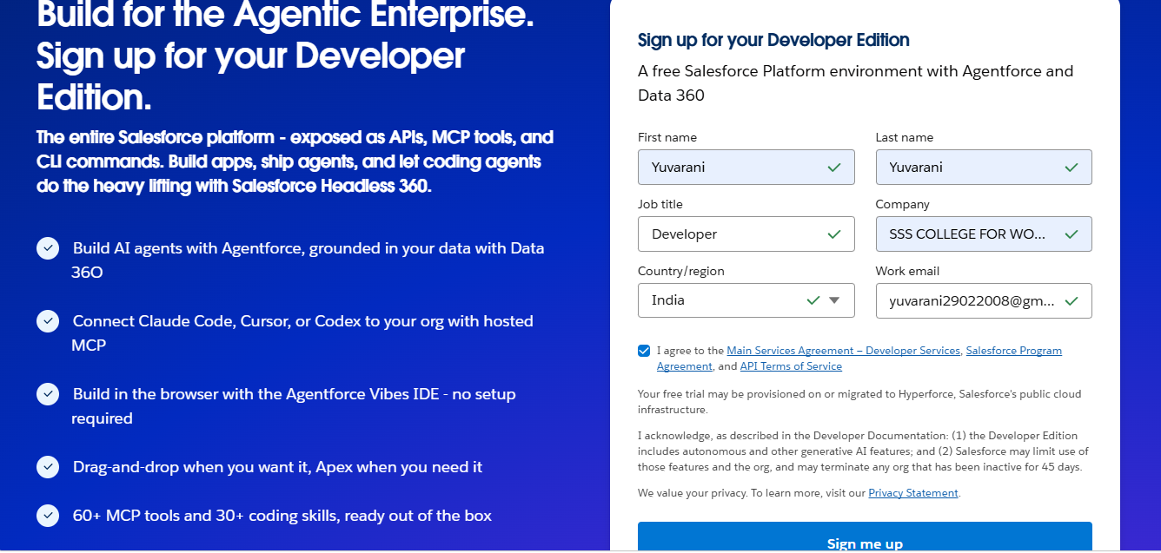

2. Fill the form:
- Name: Your name
- Email: Your email
- Role: Select Developer
- Company: Your college name
- Country: India
- Pincode: Your pincode
- Username: Give any name like this - `yourname@college.com` (This is not real email, just a username)

3. Click "Sign Me Up"

- Check your email and verify. Your account is ready!

Account Activation:

1. Open your email inbox. You will get a mail from Salesforce. It may take 5-10 minutes.
2. Open that mail and click on "Verify Account".Then Click reset password.
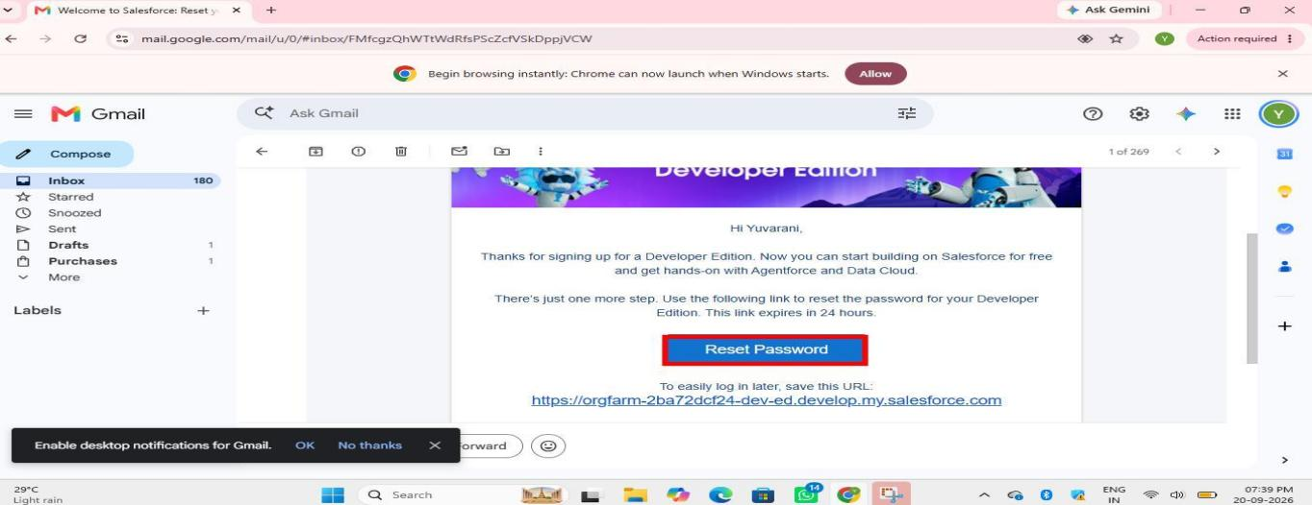
3. Now it will ask for new password and security question. Give password and choose one question and answer.
4. Click on "Change Password".
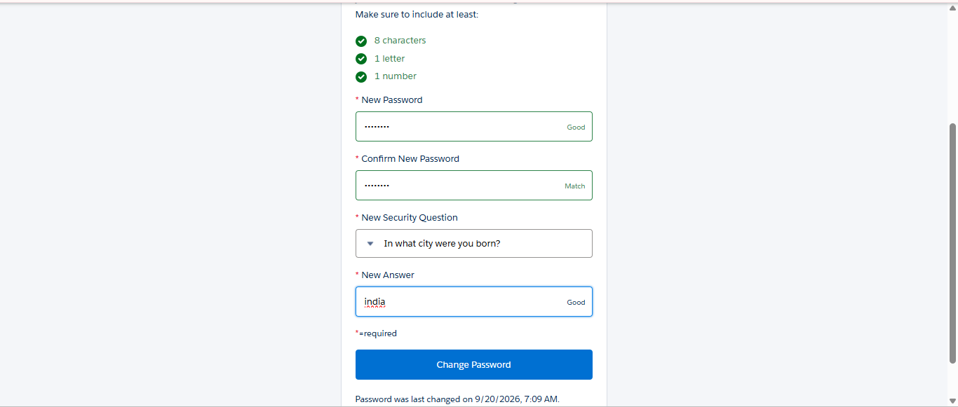

5. That's it! Now you will go to Salesforce Setup page. Your account is ready.

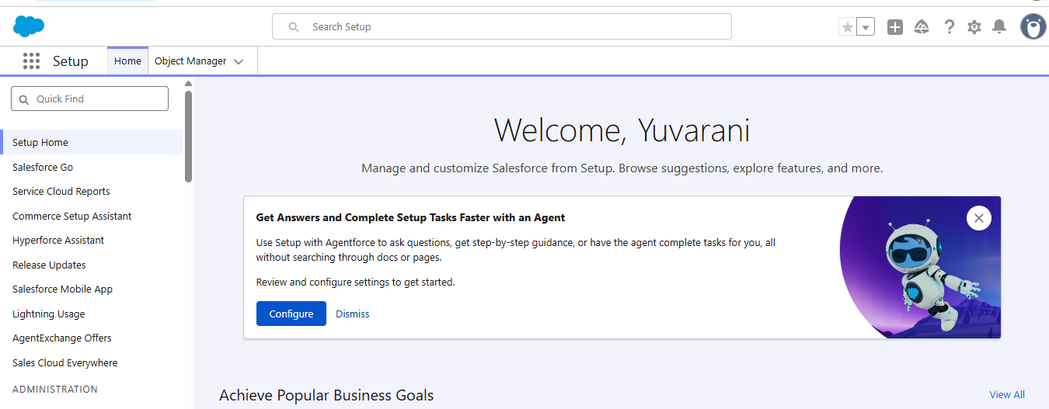

Milestone 2 - Activity 1: Creating Student Object

Purpose:
The Student object is created to store and manage student information such as personal details, contact information and enrollment status.

Procedure:
1. Go to Setup
2. Click on Object Manager
3. Click on Create and select Custom Object
4. Fill in the details:
- Label: Student
- Plural Label: Students
- Object Name: Student
- Record Name: Student Name
- Data Type: Text
5. Under Optional Features, enable:
- Allow Reports
- Allow Activities
6. Under Search Status, enable:

- Allow Search
- Click Save
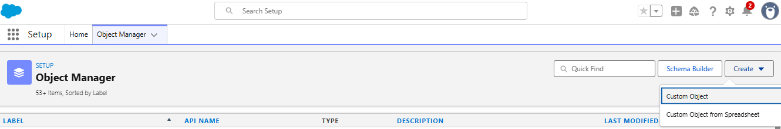
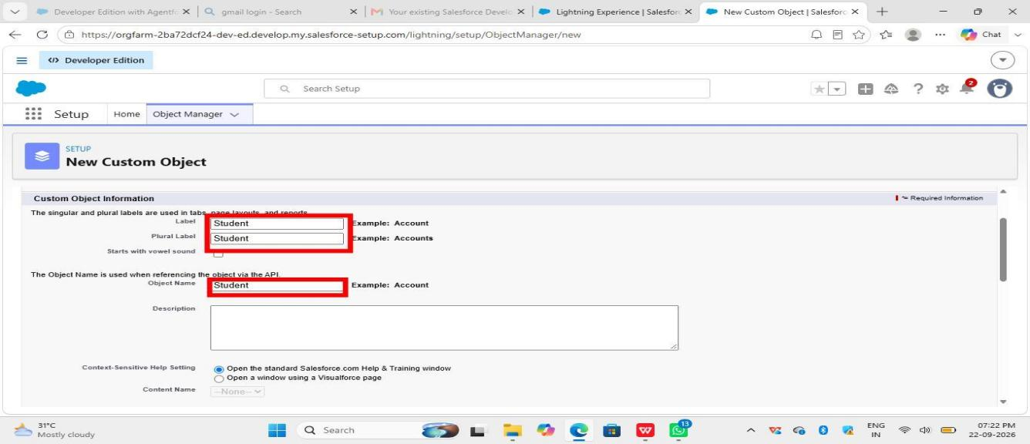
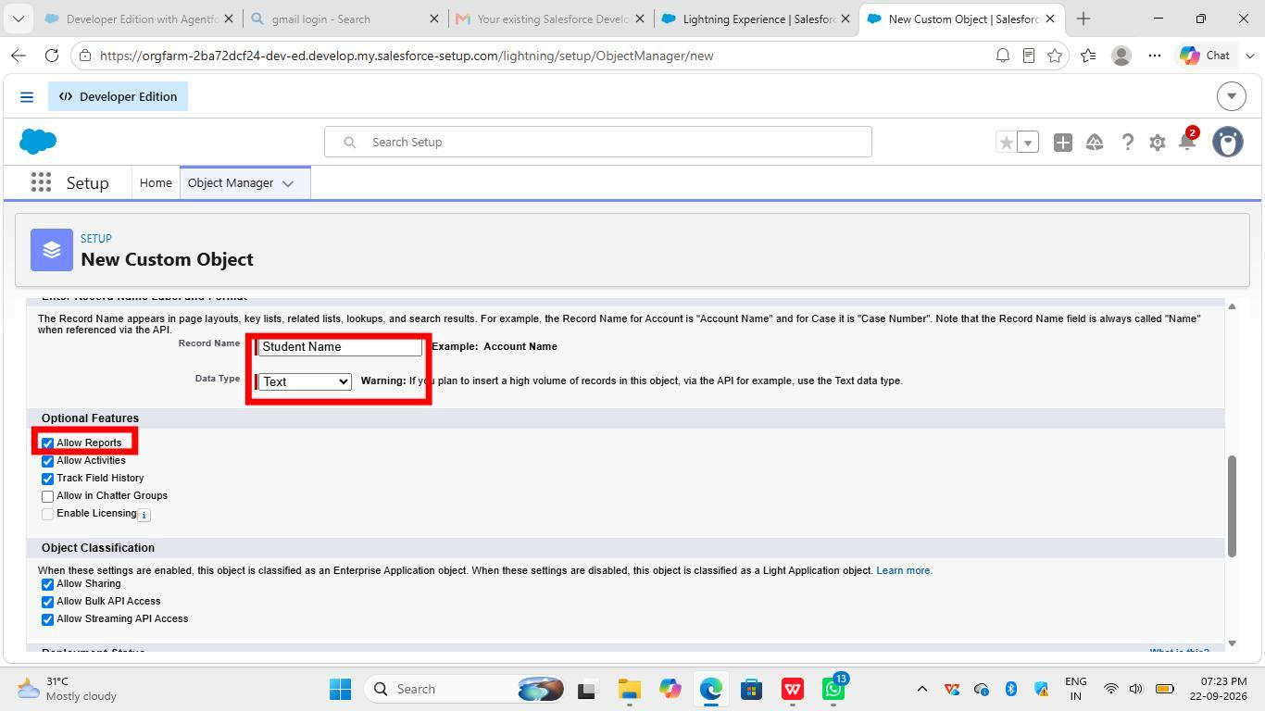
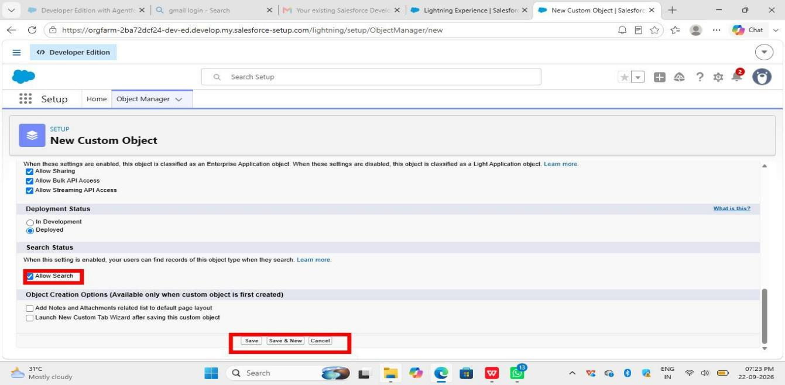

In the same way Create Courses,Instructors,and Enrolments objects.

Milestone 3 - Fields:
Student Object Fields:

1. Go to Setup
2. Click Object Manager
3. Click on Student Object
4. Click Fields & Relationships from left side
5. Click New button (top right)
6. Select Data Type as Email
7. Click Next
8. Enter Field Label as Email
9. Click Next->Next ->Save
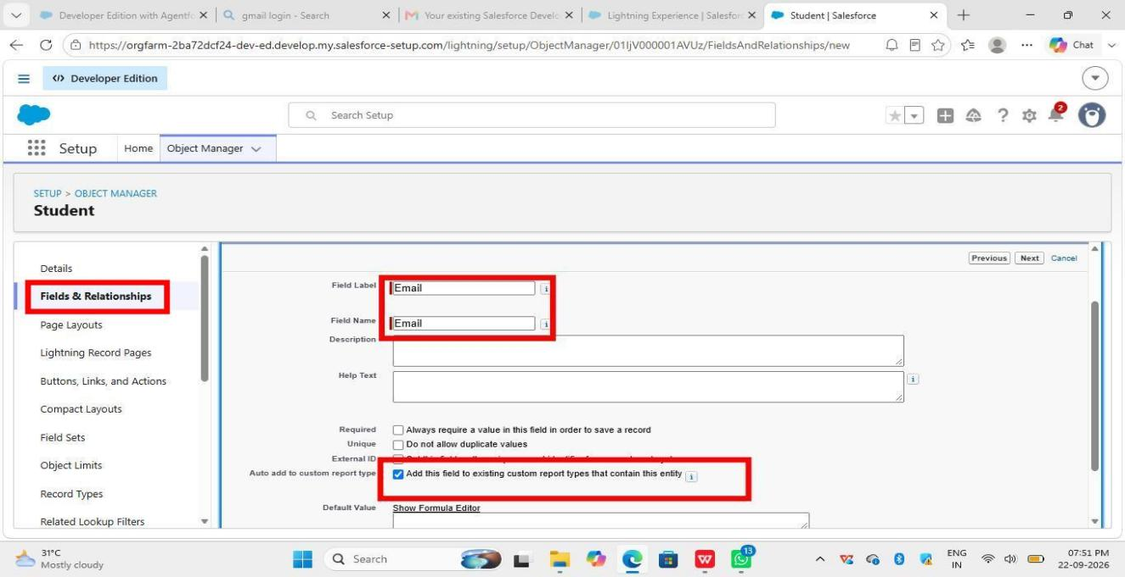

2. Phone Field:
Fields & Relationships -> New -> Data Type = Phone -> Next -> Field Label = Phone -> Next -> Next -> Save
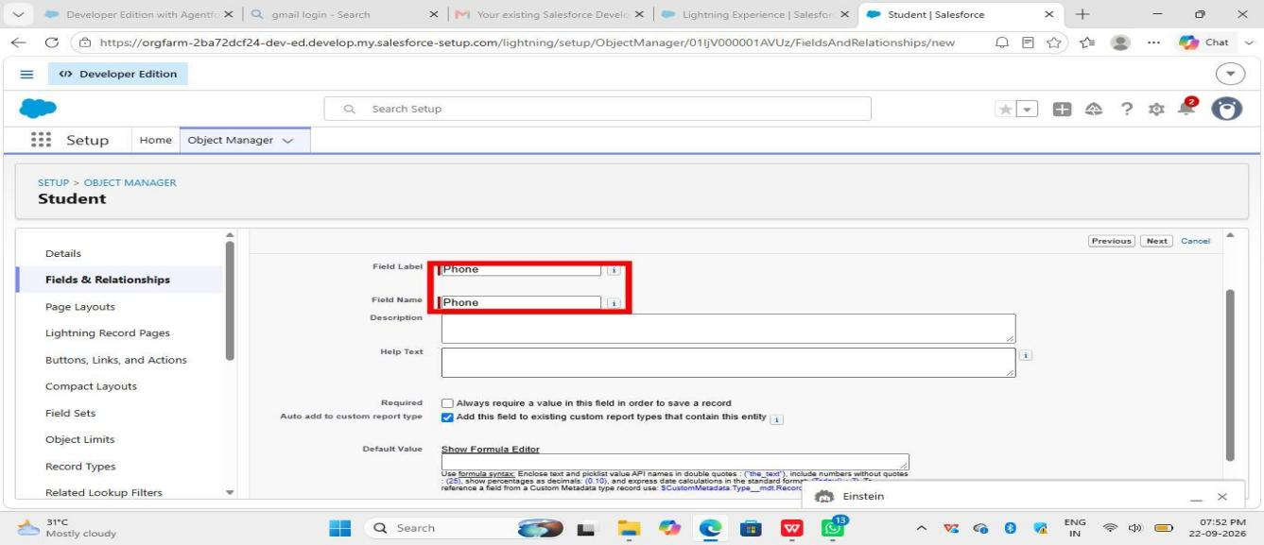
3. Date of Birth Field:
Fields & Relationships -> New -> Data Type = Date -> Next -> Field Label = Date of Birth -> Next -> Next -> Save
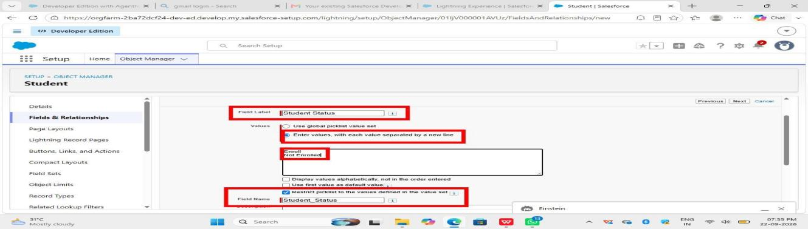

4. Student Status Field:
Fields & Relationships -> New -> Data Type = Picklist -> Next -> Field Label = Student Status -> Enter Values: Enrolled, Not Enrolled -> Next -> Next -> Save

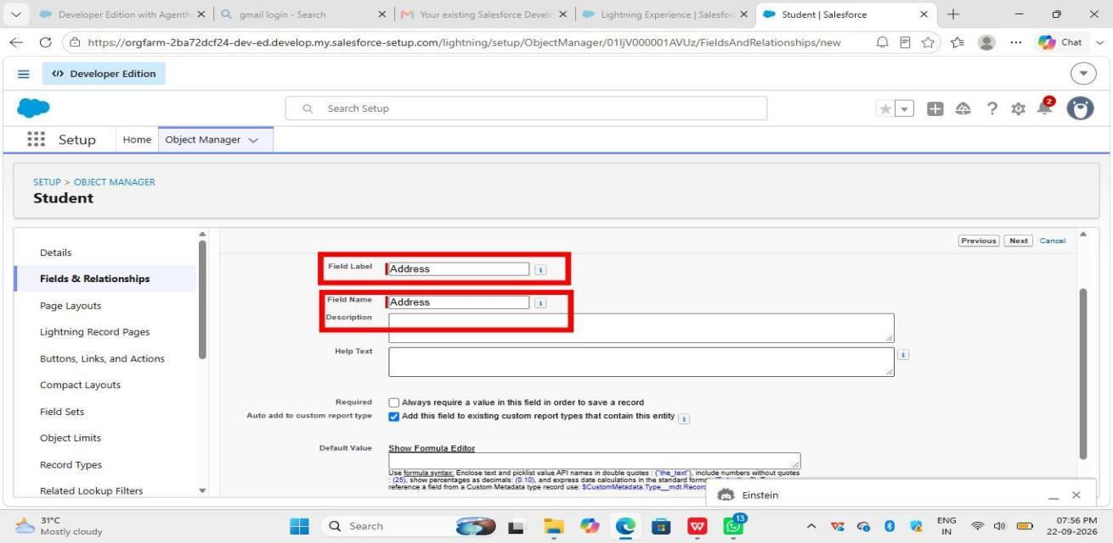

5. Address Field:
Fields & Relationships -> New -> Data Type = Text Area (Long) -> Next -> Field Label = Address -> Next -> Next -> Save
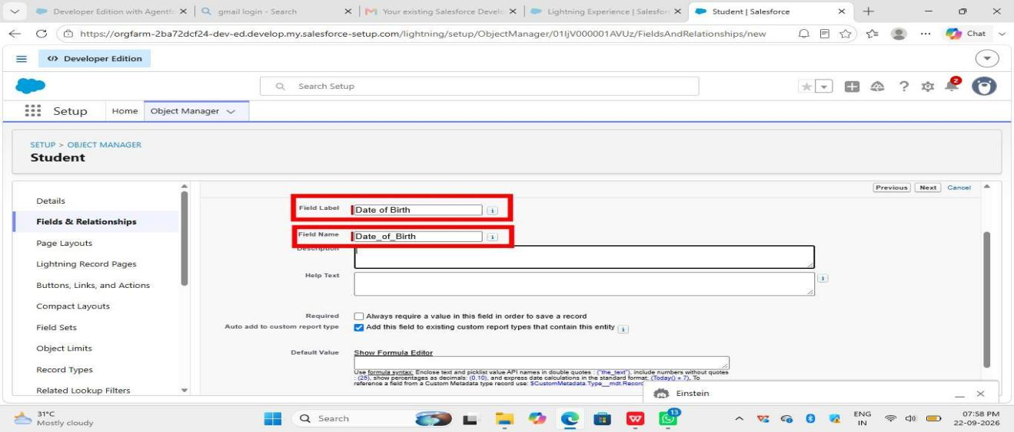

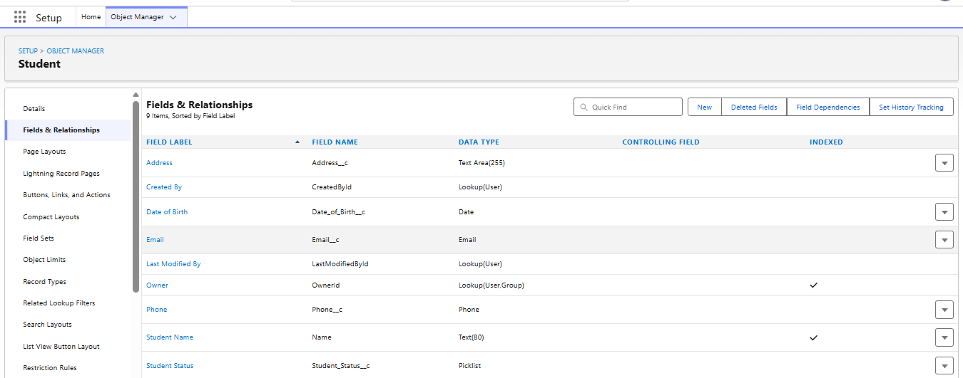

Course Object Fields:
1. Category:
New -> Data Type = Picklist -> Next -> Field Label = Category -> Enter Values: MPC, YPC, MHEC, MEC -> Next -> Next -> Save

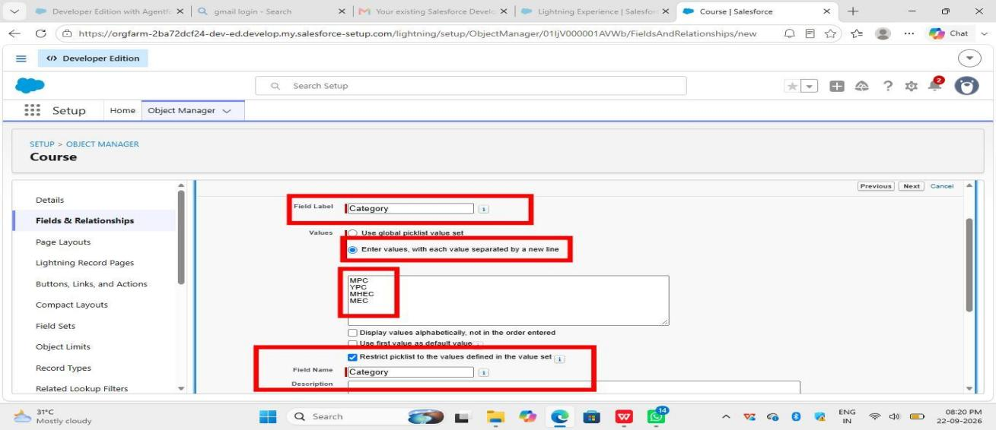
2. Duration:
New -> Data Type = Text -> Next -> Field Label = Duration -> Next -> Next -> Save
_If you want only numbers, use Number type._
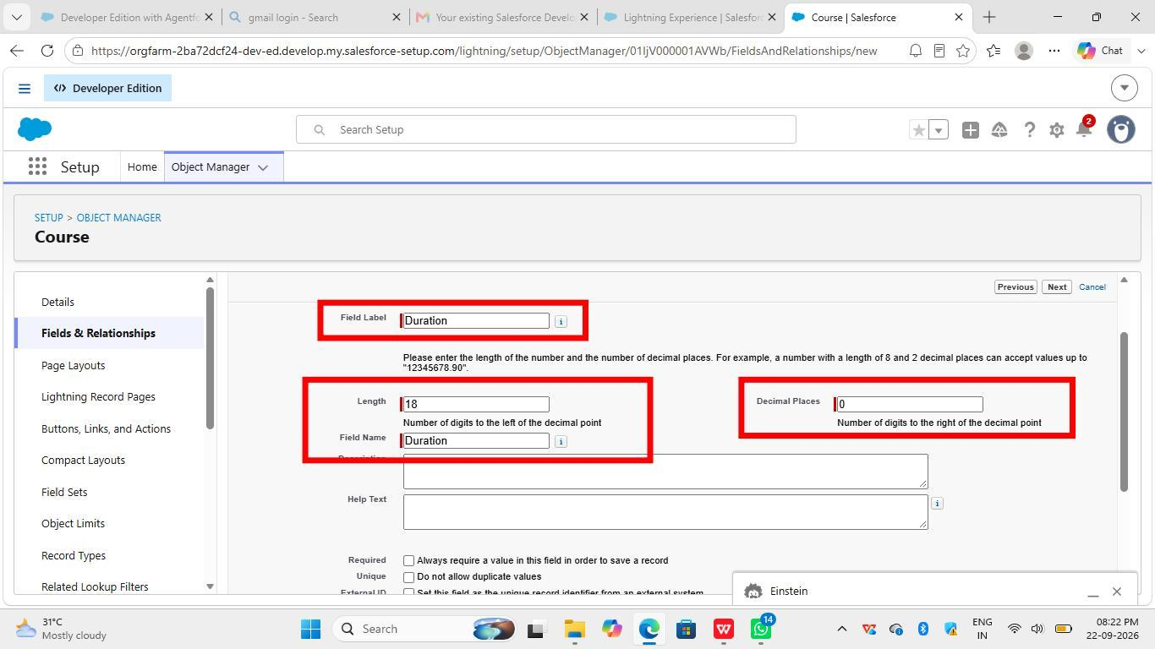

3. Course Fee:
New -> Data Type = Currency -> Next -> Field Label = Course Fee -> Next -> Next -> Save
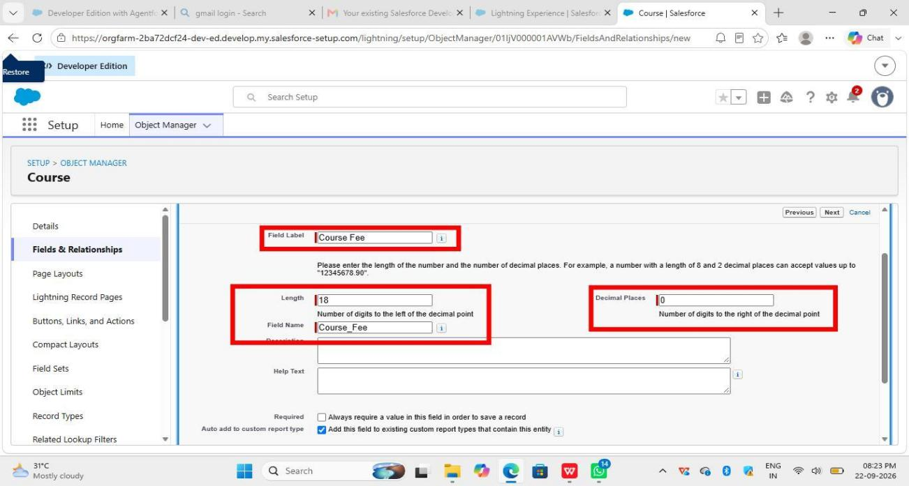

4. Description:
New -> Data Type = Text Area (Long) -> Next -> Field Label = Description -> Next -> Next -> Save

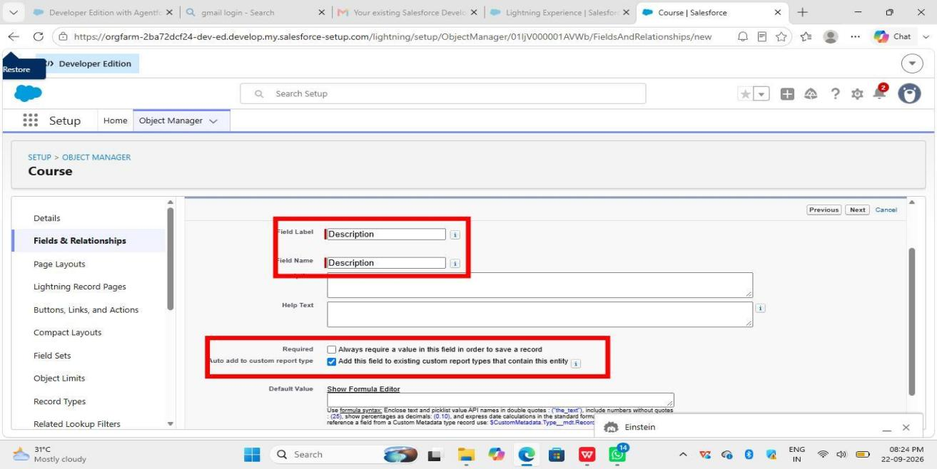

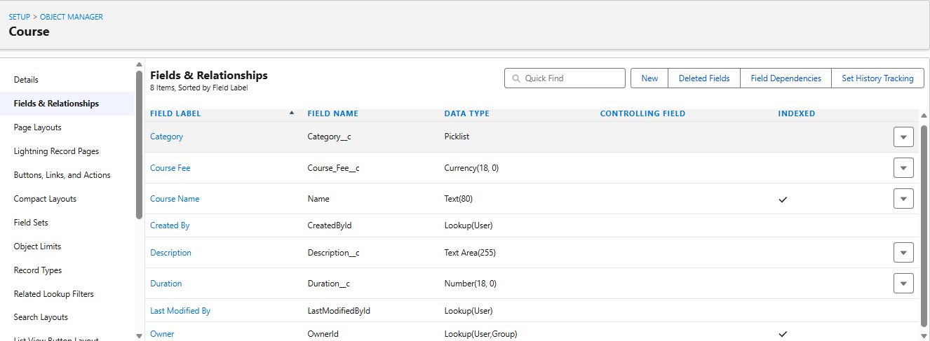

Instructor object fields
1. Instructor Code:
Fields & Relationships -> New -> Text -> Next -> Field Label = Instructor Code -> Next -> Next -> Save
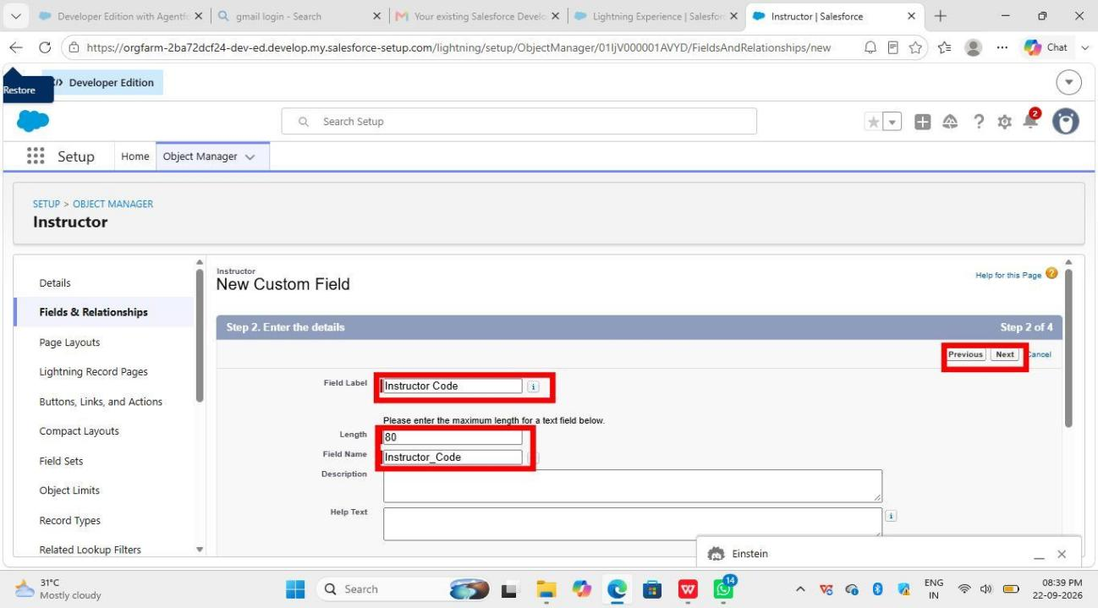

2. Expertise:
New -> Picklist -> Next -> Field Label = Expertise -> Enter Values (Ex: MPC, YPC, MHEC, MEC) -> Next -> Next -> Save
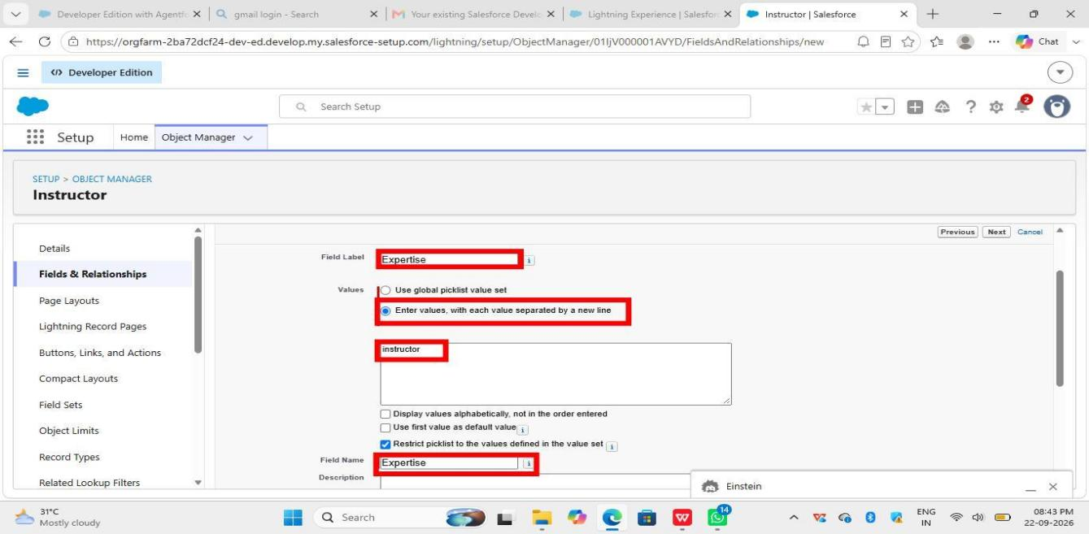

3. Phone:
New -> Phone -> Next -> Field Label = Phone -> Next -> Next -> Save

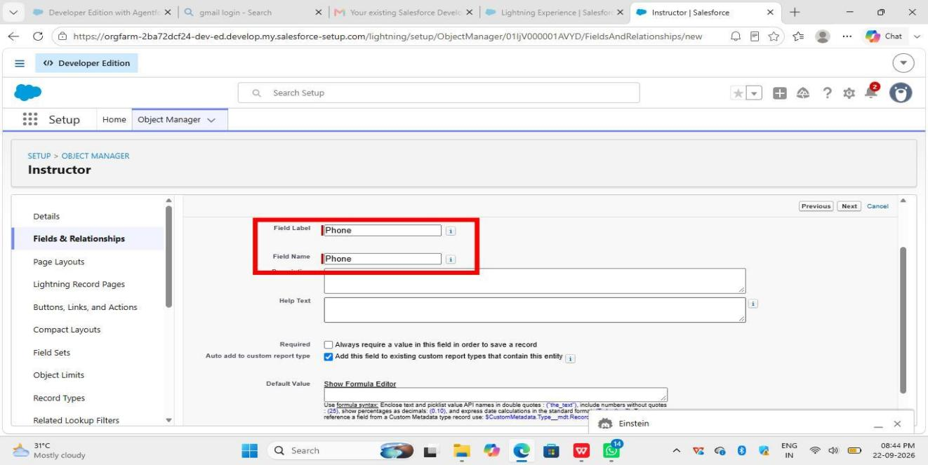

4. Email:
New -> Email -> Next -> Field Label = Email -> Next -> Next -> Save
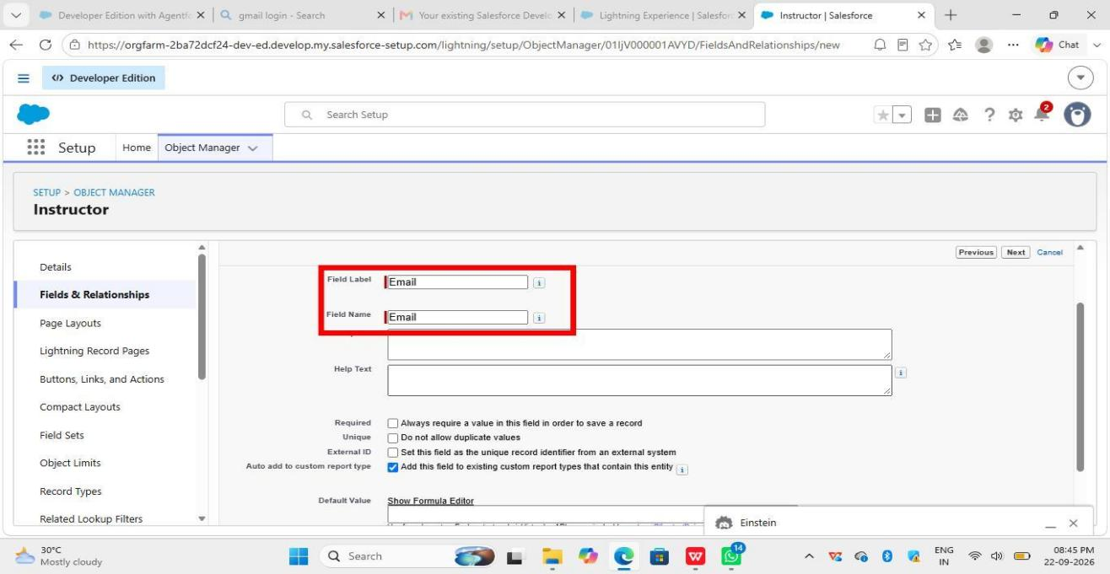

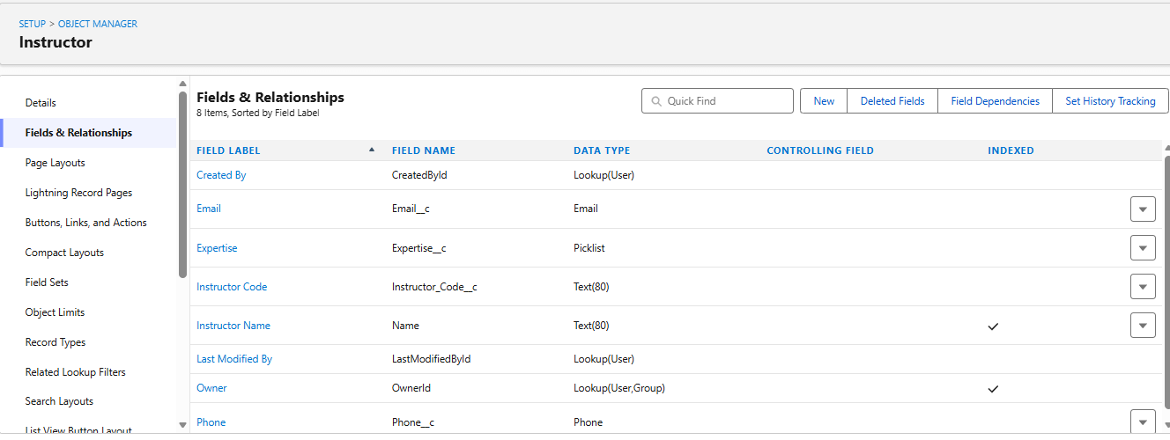

Enrollment Object - All Fields:

1. Student (Lookup to Student):
Setup -> Object Manager -> Enrollment -> Fields & Relationships -> New -> Data Type = Lookup Relationship -> Next -> Related To = Student -> Next -> Next -> Next -> Save

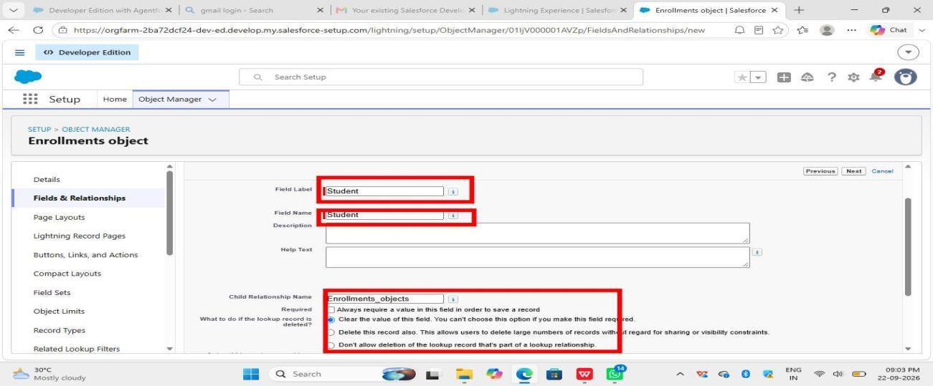

2. Course (Lookup to Course):
New -> Lookup Relationship -> Next -> Related To = Course -> Next -> Next -> Next -> Save

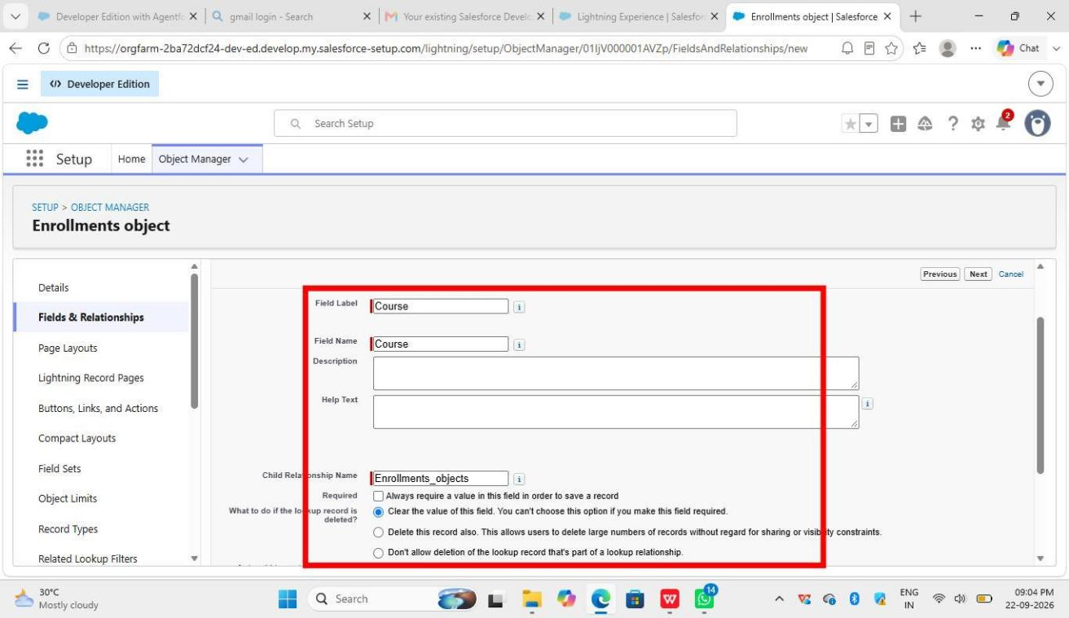

3. Instructor (Lookup to Instructor):
New -> Lookup Relationship -> Next -> Related To = Instructor -> Next -> Next -> Next -> Save

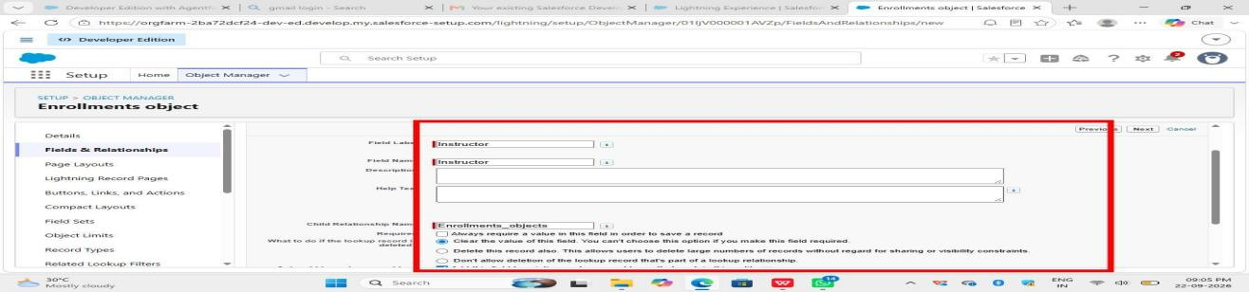

4. Enrollment Date:
New -> Date -> Next -> Field Label = Enrollment Date -> Next -> Next -> Save

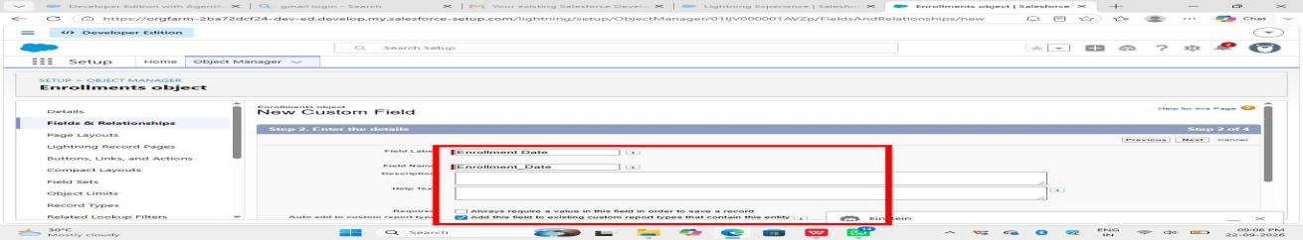
5. Enrollment Status:
New -> Picklist -> Next -> Field Label = Enrollment Status -> Values: Enrolled, Completed, Cancelled -> Next -> Next -> Save

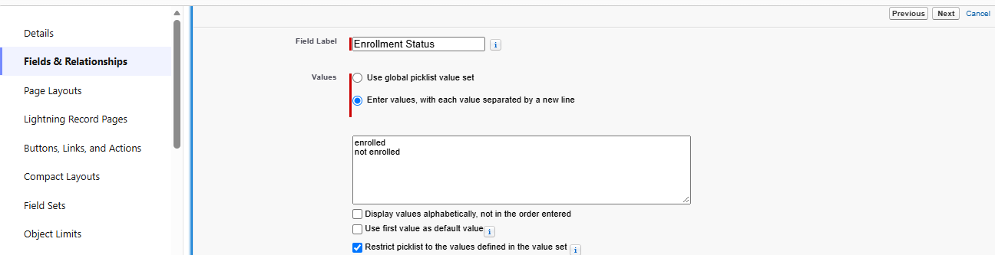

6. Fees Paid:
New -> Checkbox -> Next -> Field Label = Fees Paid -> Next -> Next -> Save

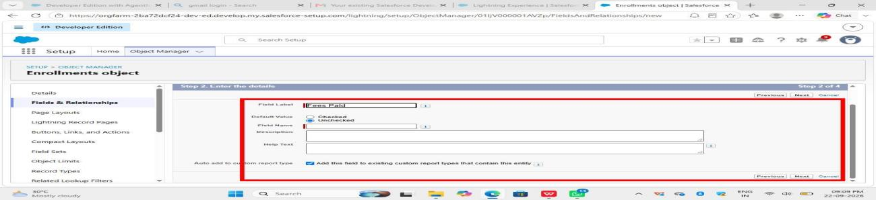

7. Total Amount:
New -> Currency -> Next -> Field Label = Total Amount -> Next -> Next -> Save

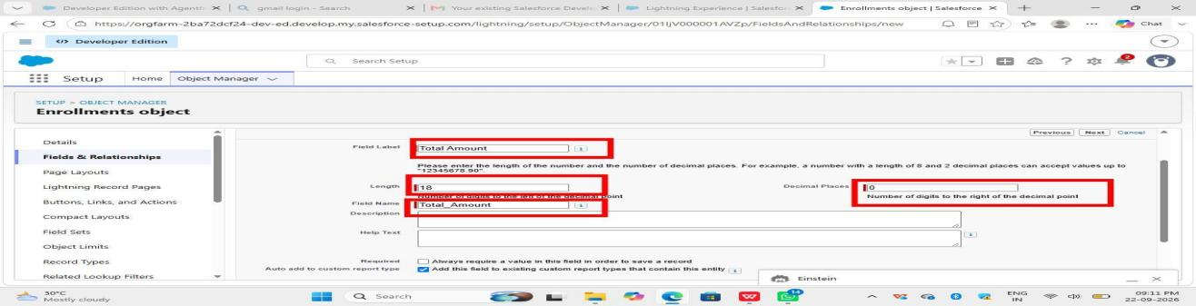
8. Comments:
New -> Text Area (Long) -> Next -> Field Label = Comments -> Next -> Next -> Save

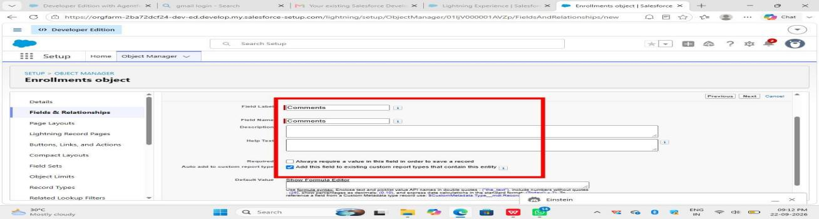

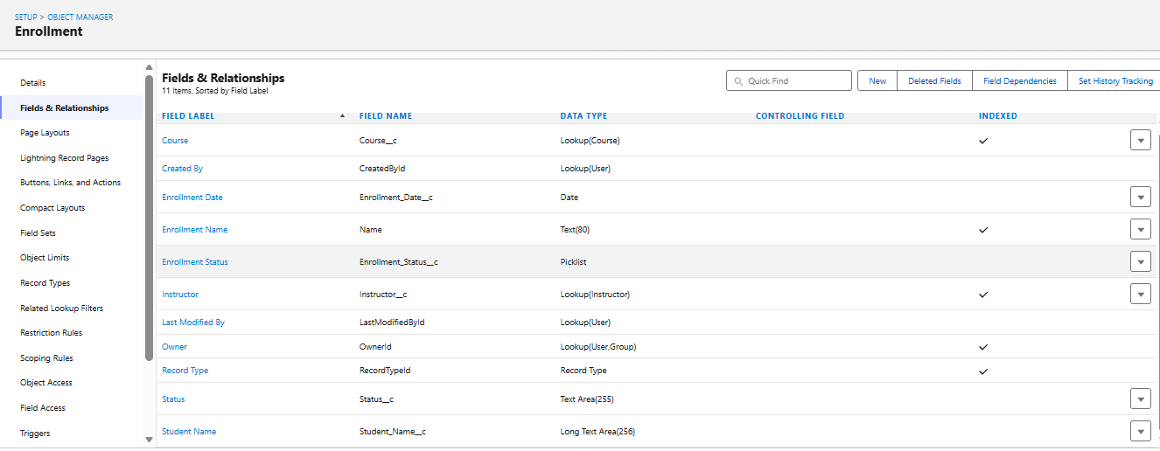

Milestone 4 – Create Relationships:
Activity 1: Create Lookup from Enrollment to Student:
1. Go to Setup
2. Open Object Manager
3. Find Enrollment_c
4. Go to Fields & Relationships
5. Click New
6. Choose Lookup Relationship
7. Choose Student object
8. Name it Student
9. Click Save

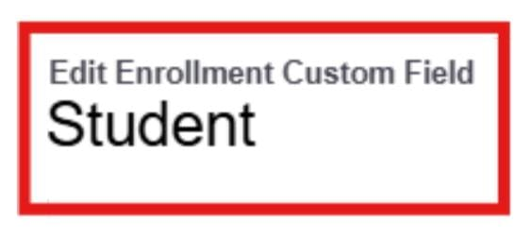
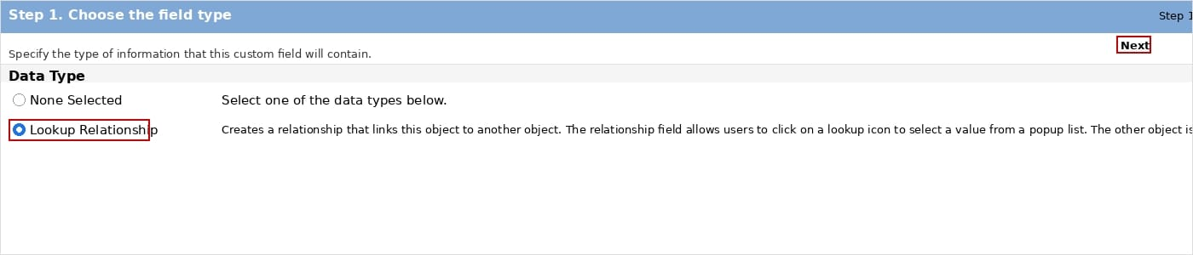

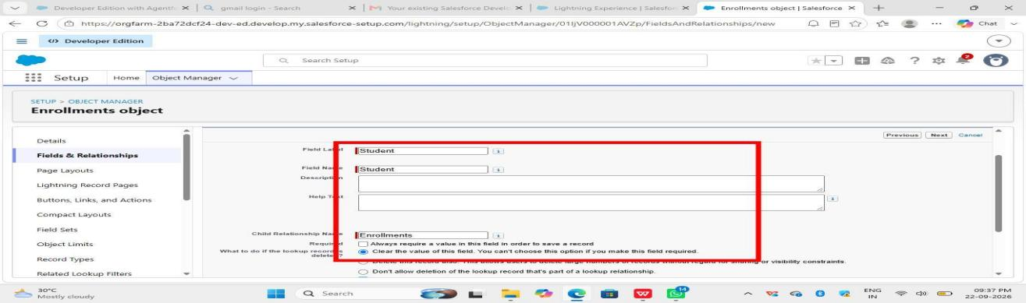
Activity 2 - Super Easy:
Purpose: To connect Enrollment with Course.

Steps:
1. Setup -> Object Manager -> Enrollment__c
2. Fields & Relationships -> New
3. Lookup Relationship -> Next
4. Related To -> Course__c -> Next
5. Field Label -> *Course*
6. Next -> Next -> Save



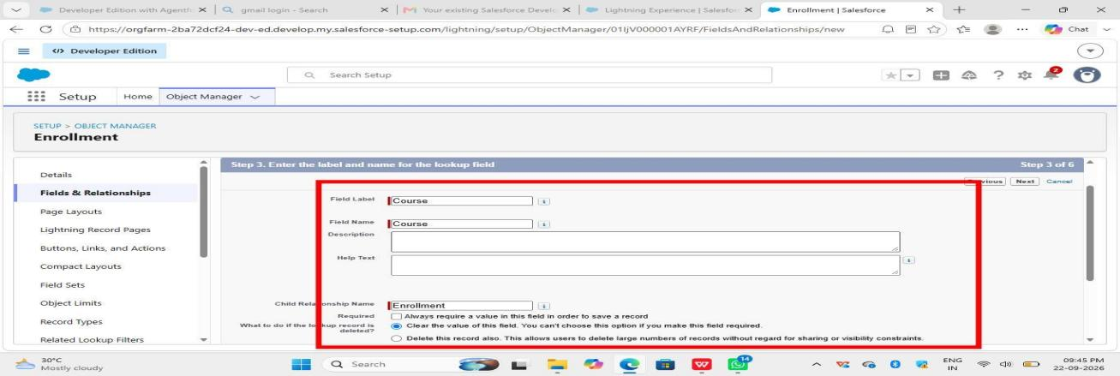

Activity 3: Instructor Lookup

Purpose:To know which Instructor is teaching that Enrollment.

Steps:
1. Go to Setup -> Object Manager -> Enrollment__c
2. Click Fields & Relationships -> New
3. Select Lookup Relationship -> Next
4. Select Instructor__c as Related To -> Next
5. Give Field Label as Instructor
6. Click Next, Next and Save

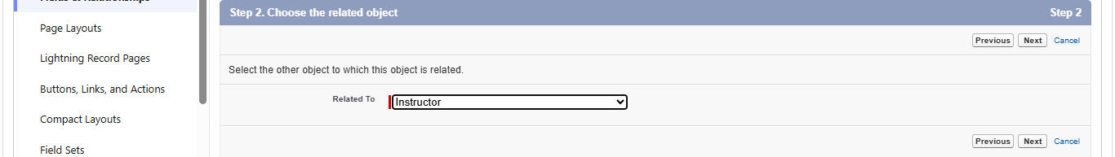

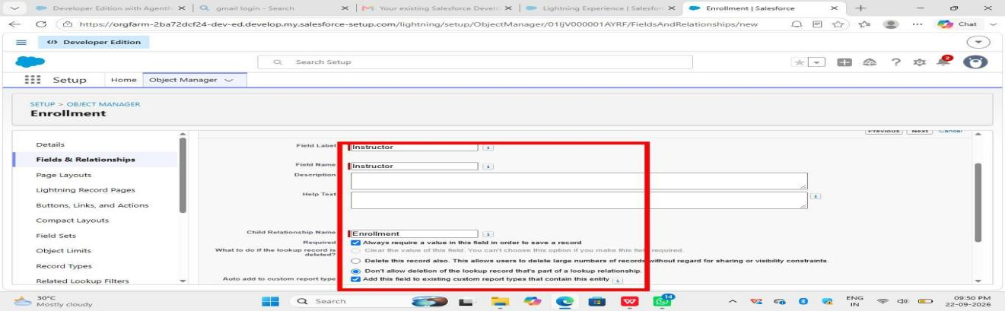

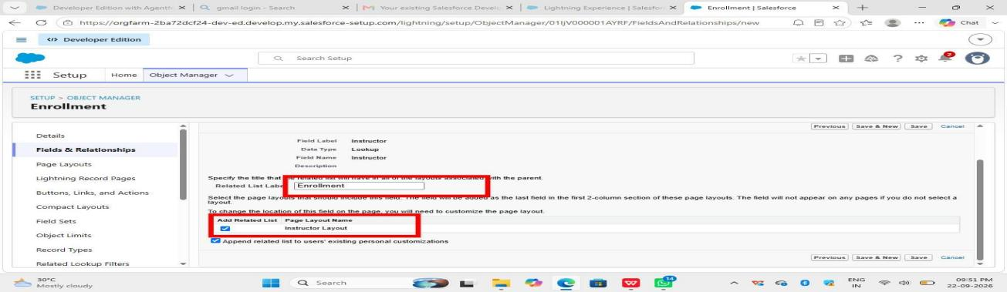

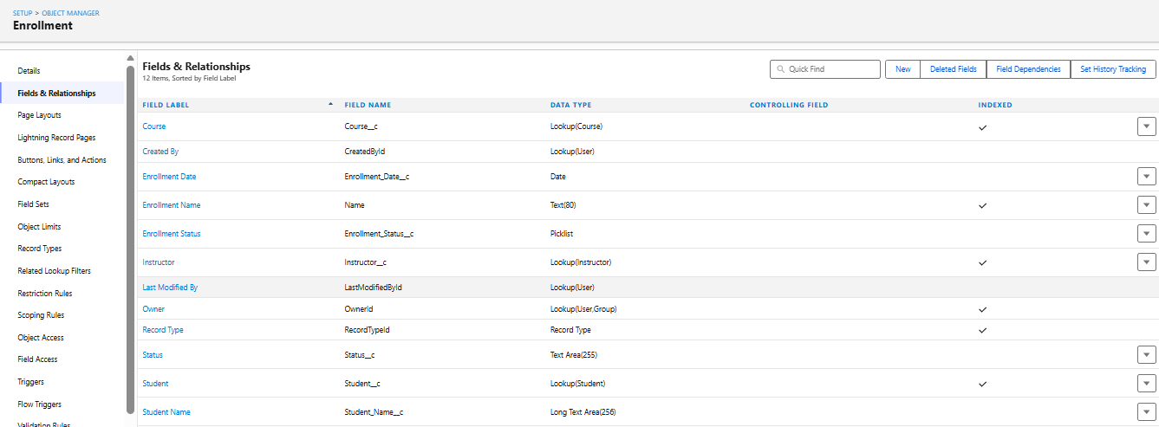

Milestone 5 – Activity 1: Student Email Domain Validation

Purpose:To ensure students use only allowed institutional email addresses.

Steps:
1. Go to Setup → Object Manager → Student__c.
2. Click Validation Rules → New.
3. Rule Name: Student_Email_Domain_Validation.
4. Error Condition Formula: `NOT(CONTAINS(Email__c, "@student.edu"))`
5. Error Message: Email must be a valid student institutional email.
6. Error Location: Field → Email__c.
7. Click Save.

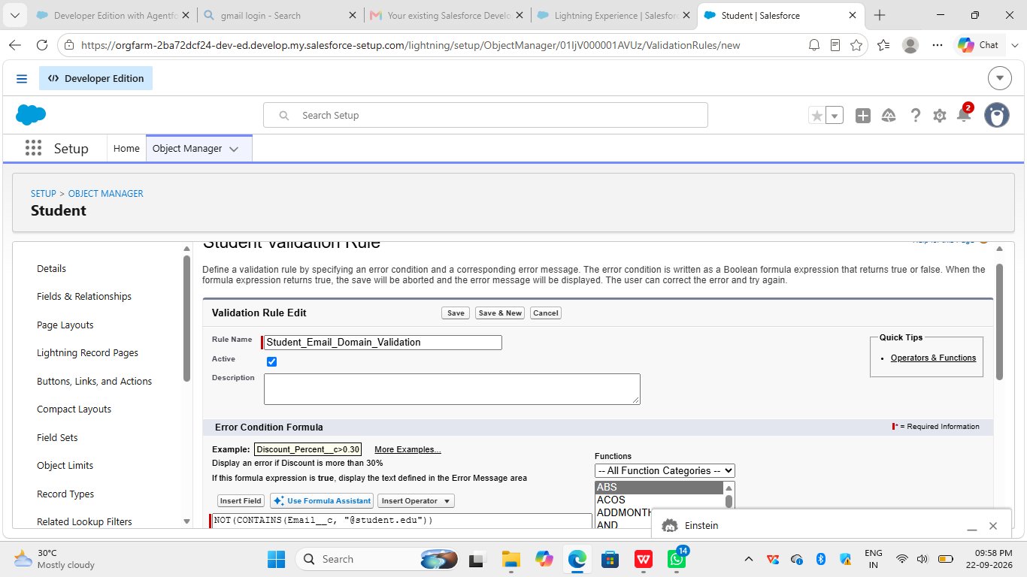

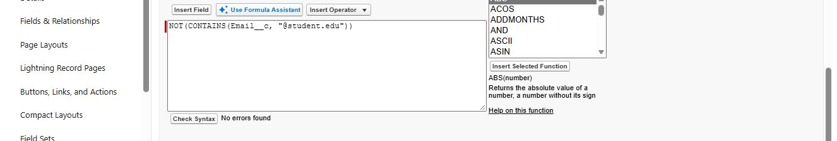

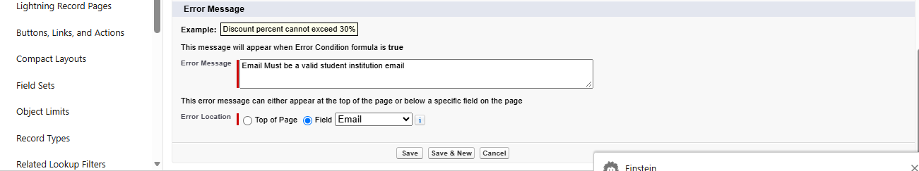

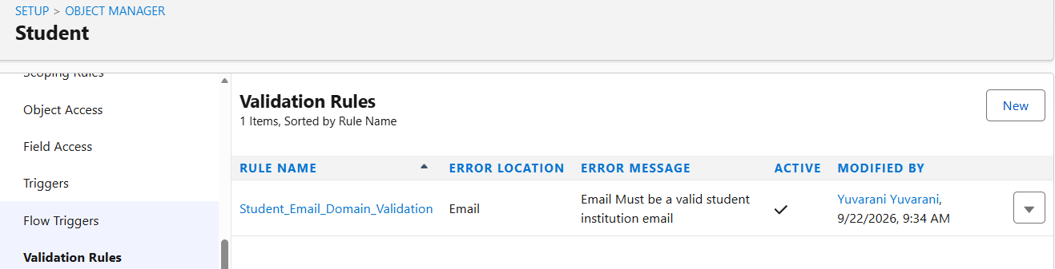

Activity 2: Fees Must Be Paid Before Approval

Purpose: Prevent Enrollment from being approved until fees are paid.

Steps:
1. Go to Setup → Object Manager → Enrollment__c.
2. Click Validation Rules → New.
3. Rule Name: Fees_Must_Be_Paid_Before_Approval.
4. Error Condition Formula:
AND(
ISPICKVAL(Enrollment_Status__c, "Approved"),
Fees_Paid__c = FALSE
)
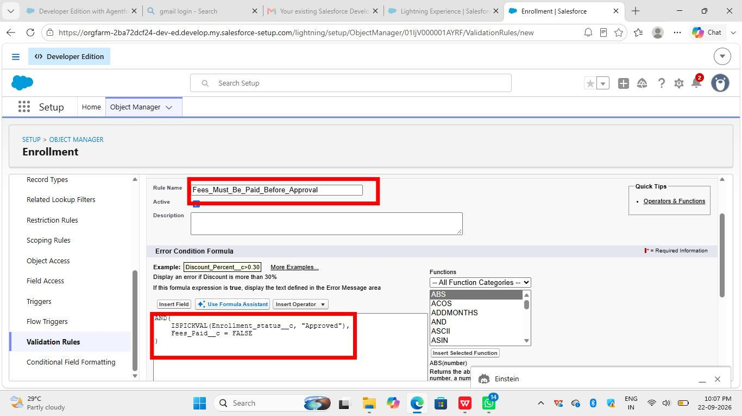
5. Error Message: 6. Error Location: Top of Page
7. Click Save.

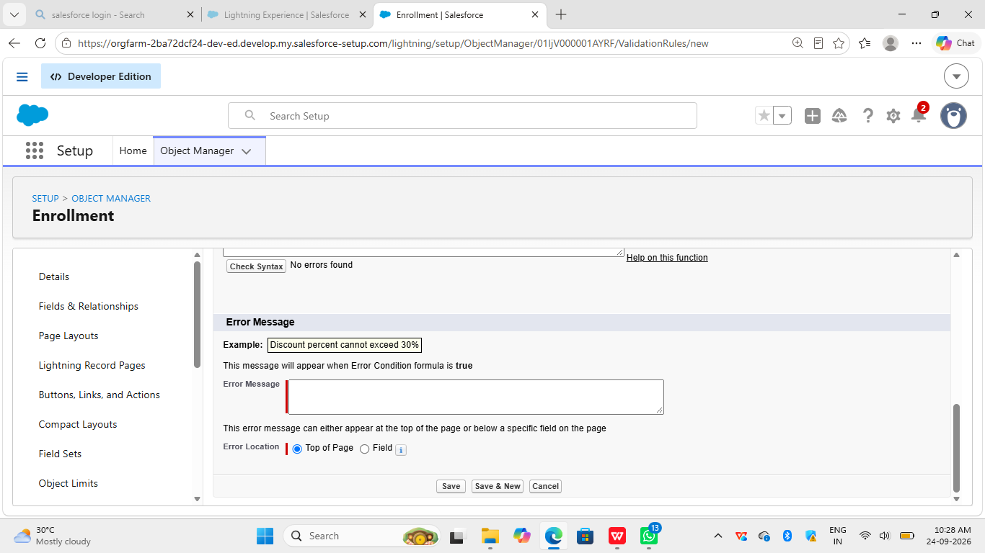
Fees must be paid before approving an enrollment.

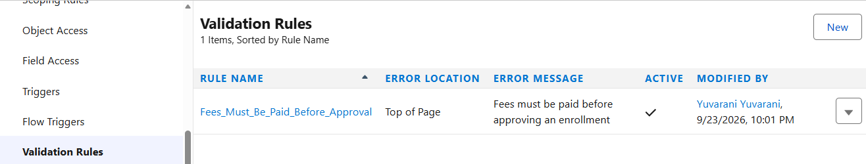

Milestone 6 – Approval Process
Activity 1: Create Approval Process for Enrollment Requests

Approval 1: Enrollment Request Approval

1. Go to Setup and search for `Approval Processes`
2. In "Manage Approval Processes For" select Enrollment__c
3. Click `Create New Approval Process > Use Standard Setup Wizard`
4. Name: `Enrollment Approval Request`
5. Set Entry Criteria:
Field: Enrollment__c : Status__c
Operator: equals
Value: Requested
6. Assign Approver (Manager / Course Instructor)
7. Click Next > Next > Save

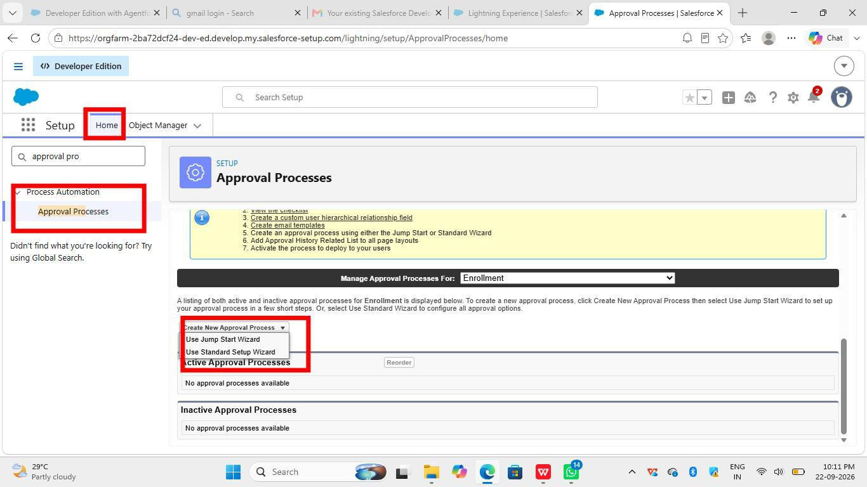

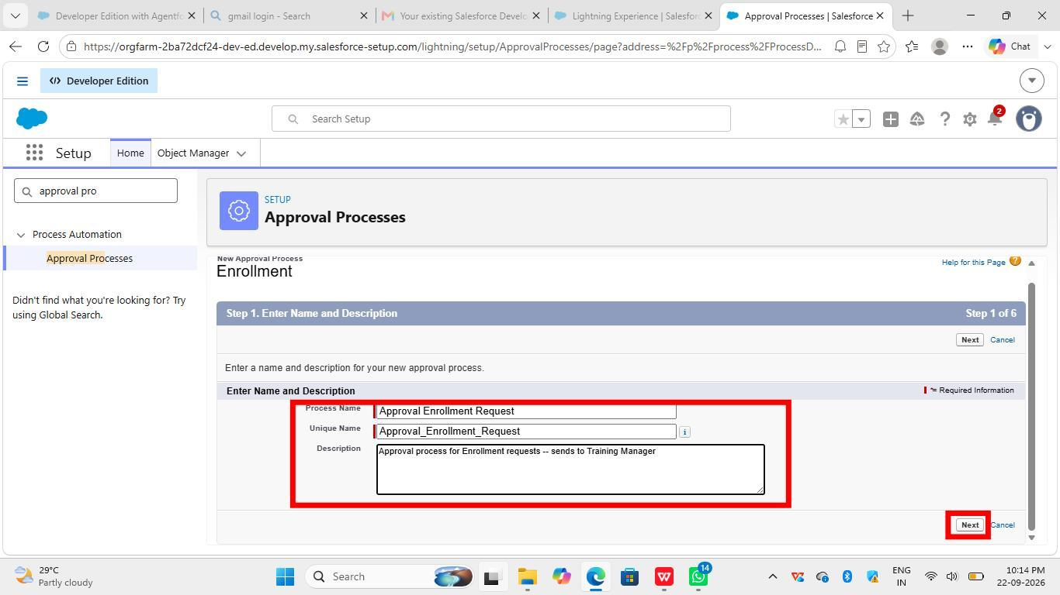

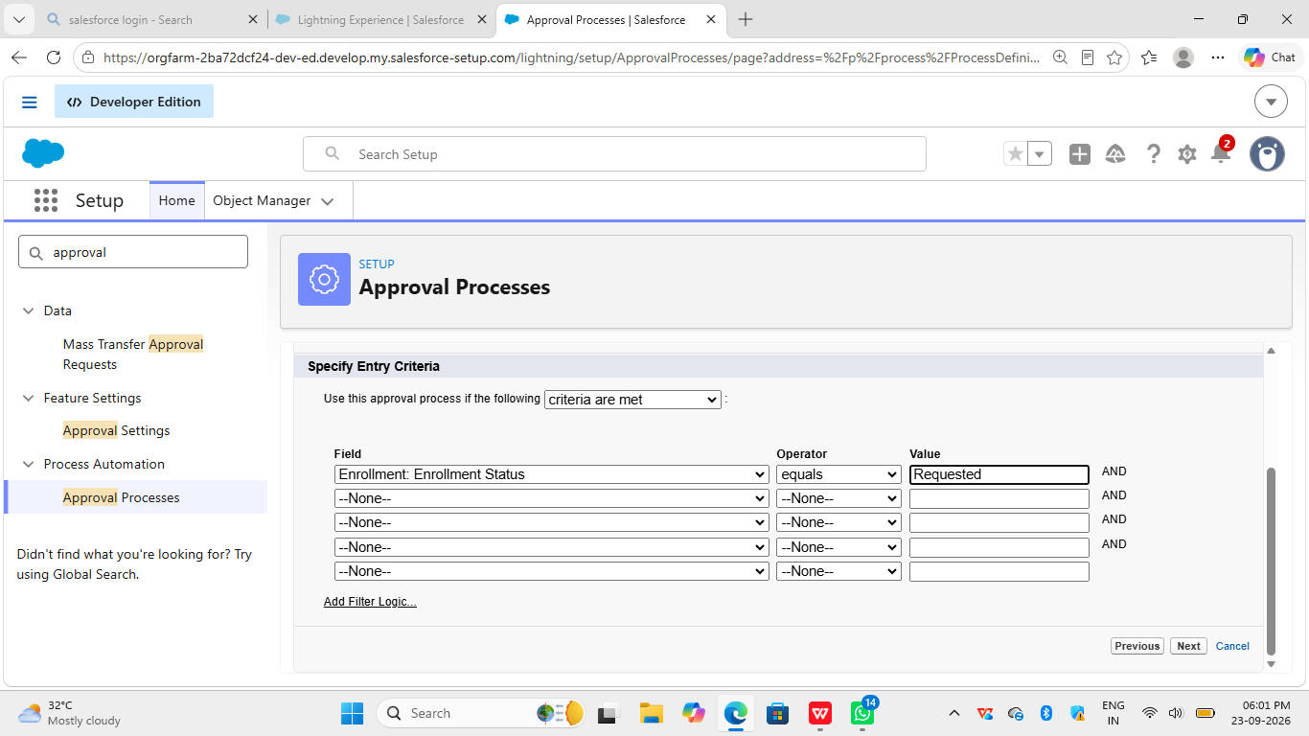

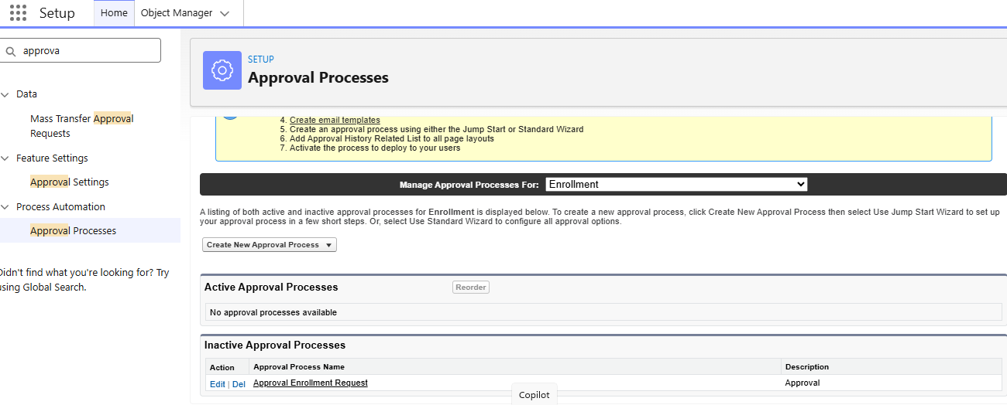

Approval 2: Training Manager Approval

1. Create another approval process the same way
2. Name: `Training Manager Approval`

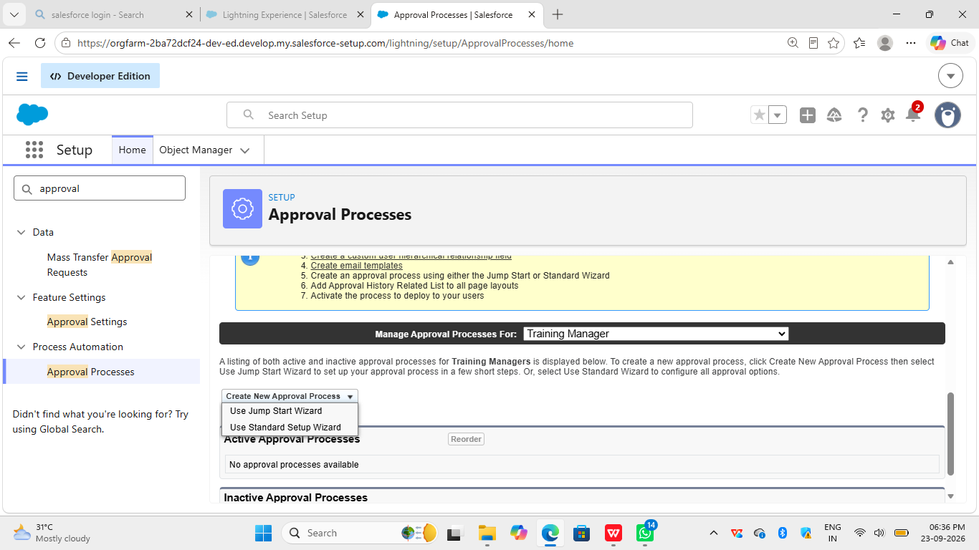

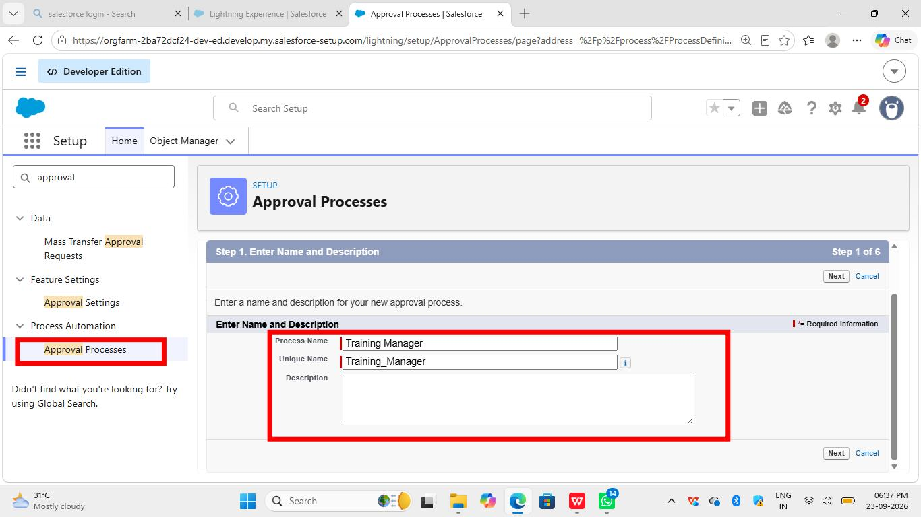

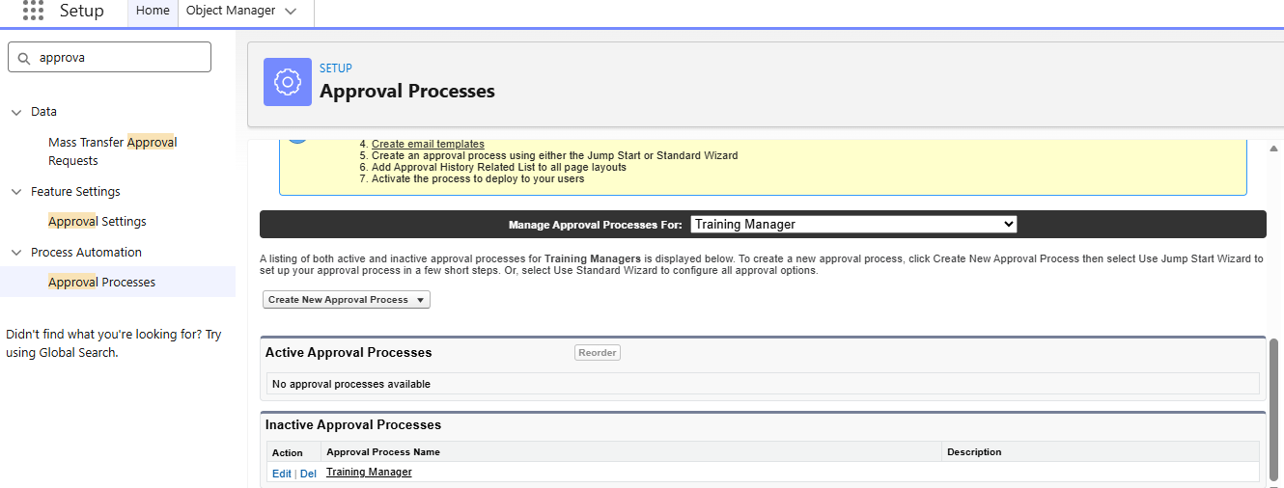
Create Field Updates:

Go to Setup > Approval Process > Field Updates > New

1. Approved Update:
- Name: `Set Status to Approved`
- Object: Enrollment__c
- Field to Update: `Status__c`
- New Value: `Approved`

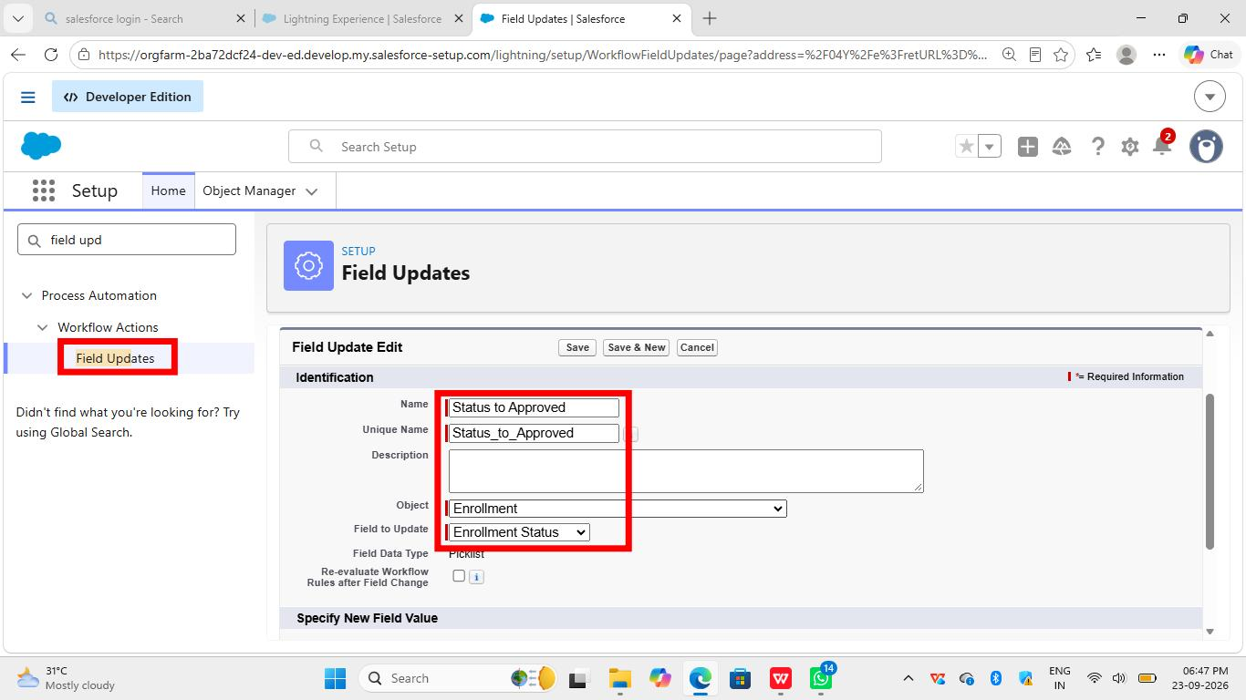

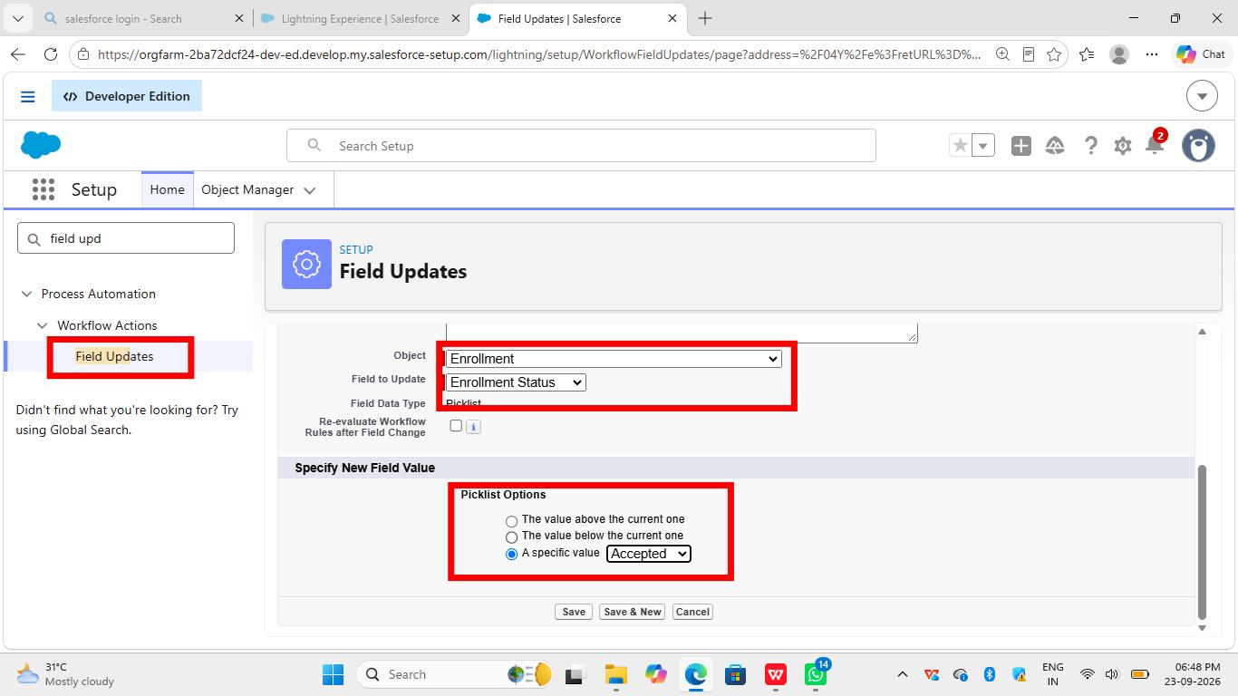

2. Rejected Update:
- Name: `Set Status to Rejected`
- Object: Enrollment__c
- Field to Update: `Status__c`
- New Value: `Rejected`

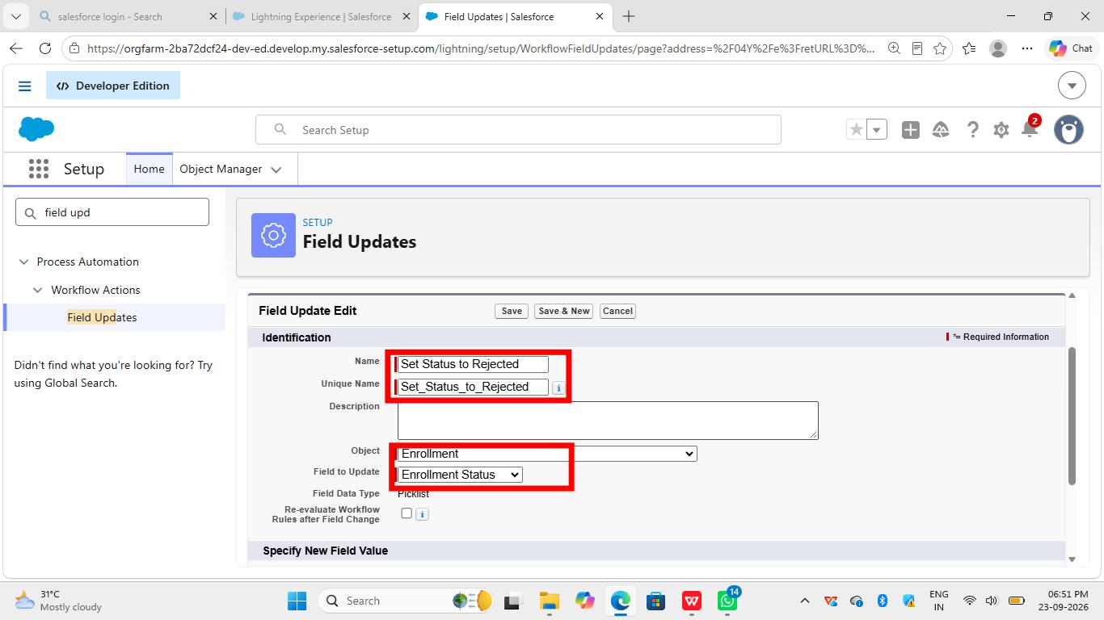

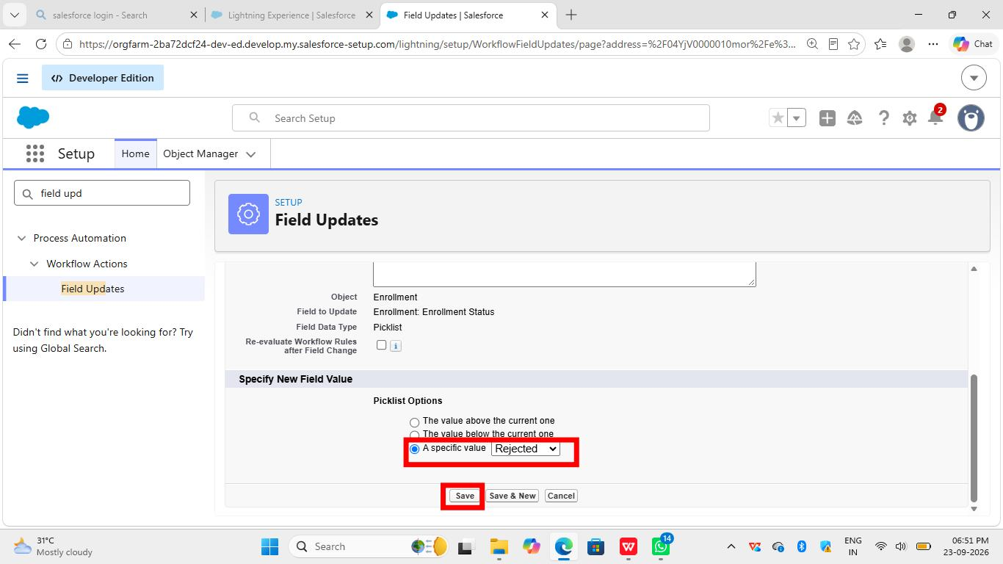
Create Email Alert:

1. Go to Setup > `Email Alerts` > New
2. Description: `Enrollment Rejected`
3. Object: Enrollment__c
4. Email Template: `Enrollment Rejected`
5. Recipient Type: User > Student / Owner
6. Save

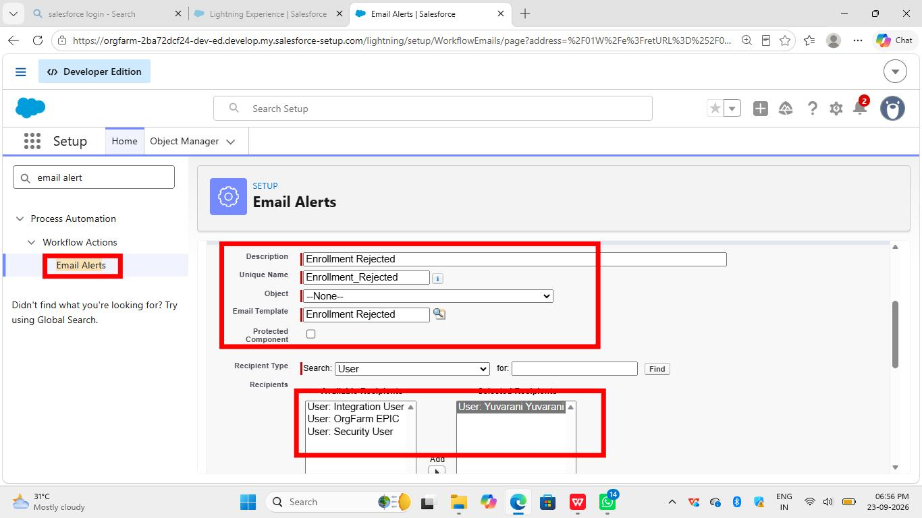

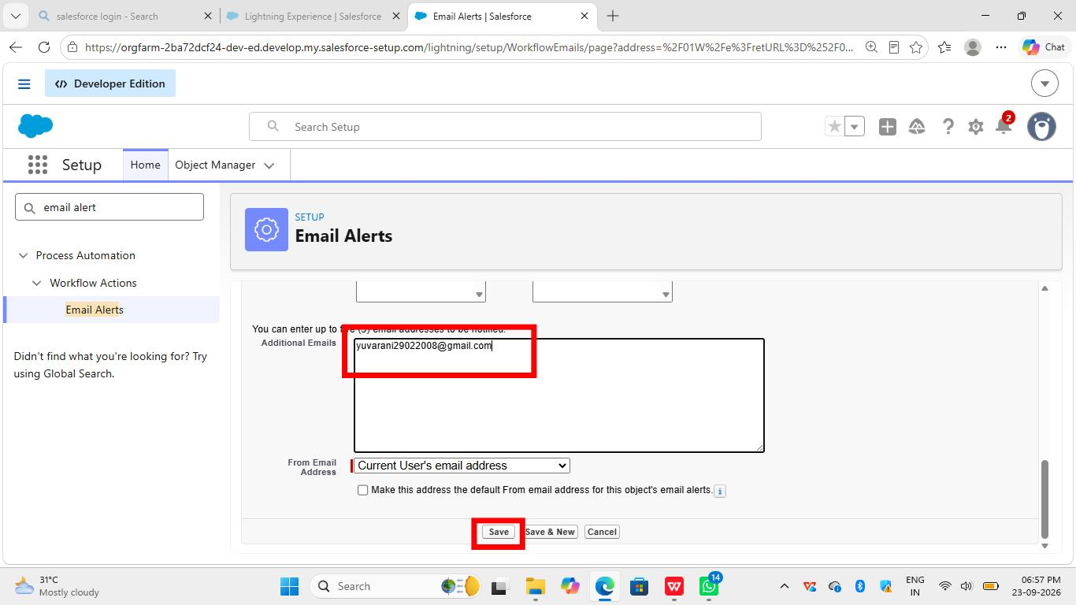

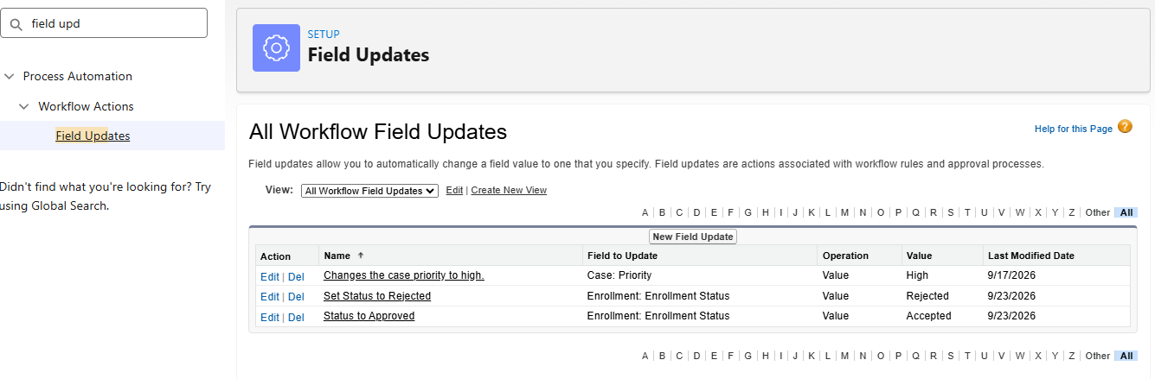
Milestone 7: Tabs
For student Tab:

1. Click Setup.
2. Search Tabs.
3. Click New under Custom Object Tabs.
4. Select Student object.
5. Choose an icon.
6. Click Next, then Save.
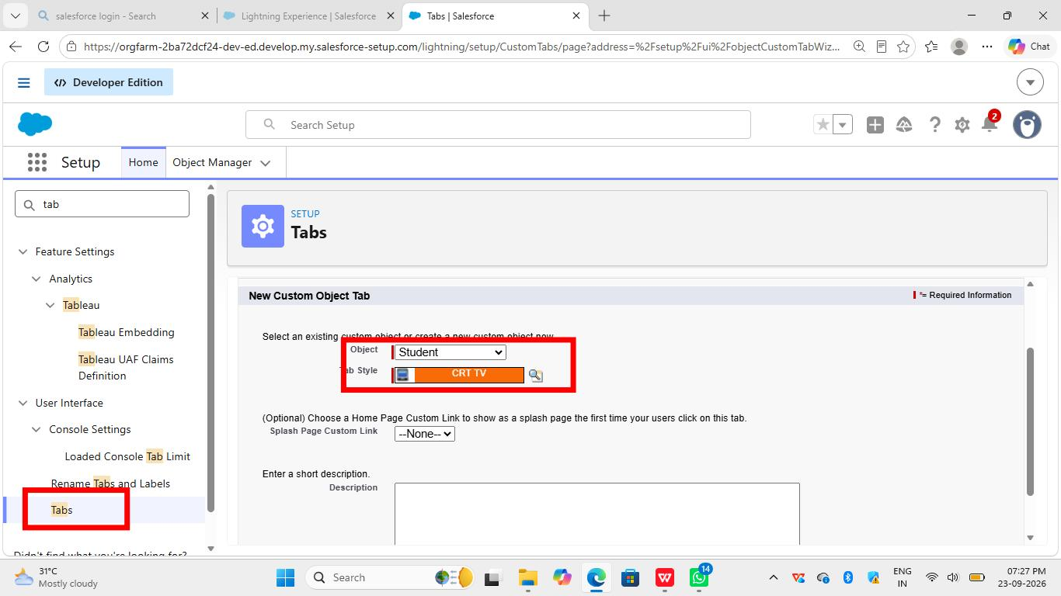

Activity 2: Creating Remaining Tabs

For Course Tab:

1. Click Setup.
2. Search Tabs.
3. Click New.
4. Select Course object.
5. Choose icon.
6. Click Next, then Save.

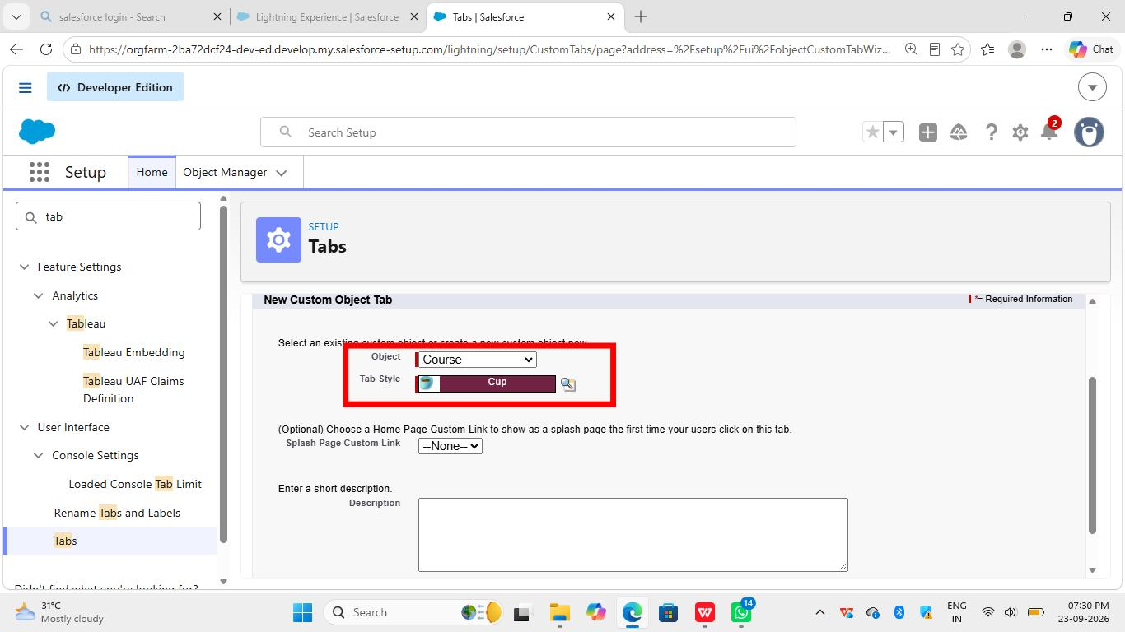

For Instructor Tab.

1. Click Setup.
2. Search Tabs.
3. Click New.
4. Select Instructor object.
5. Choose icon.
6. Click Next, then Save.
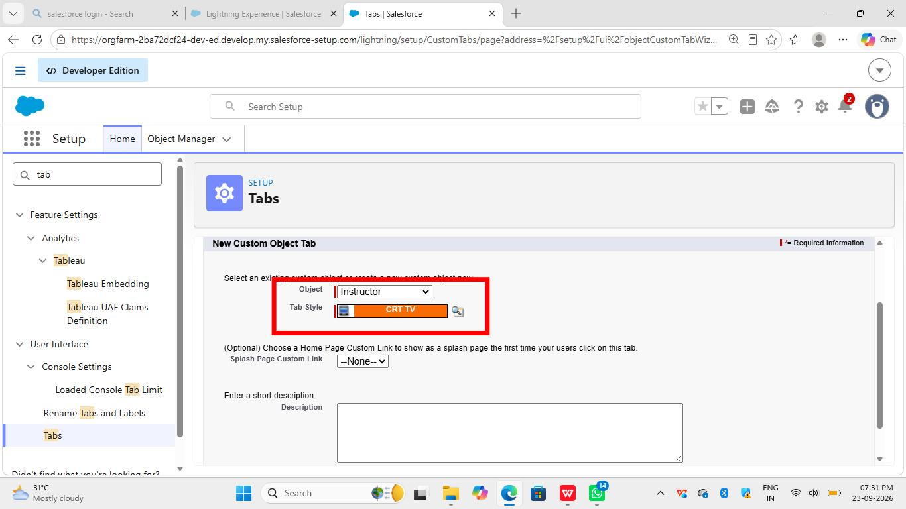
For Enrollment Tab:
1. Click Setup.
2. Search Tabs.
3. Click New.
4. Select Enrollment object.
5. Choose icon.
6. Click Next, then Save.
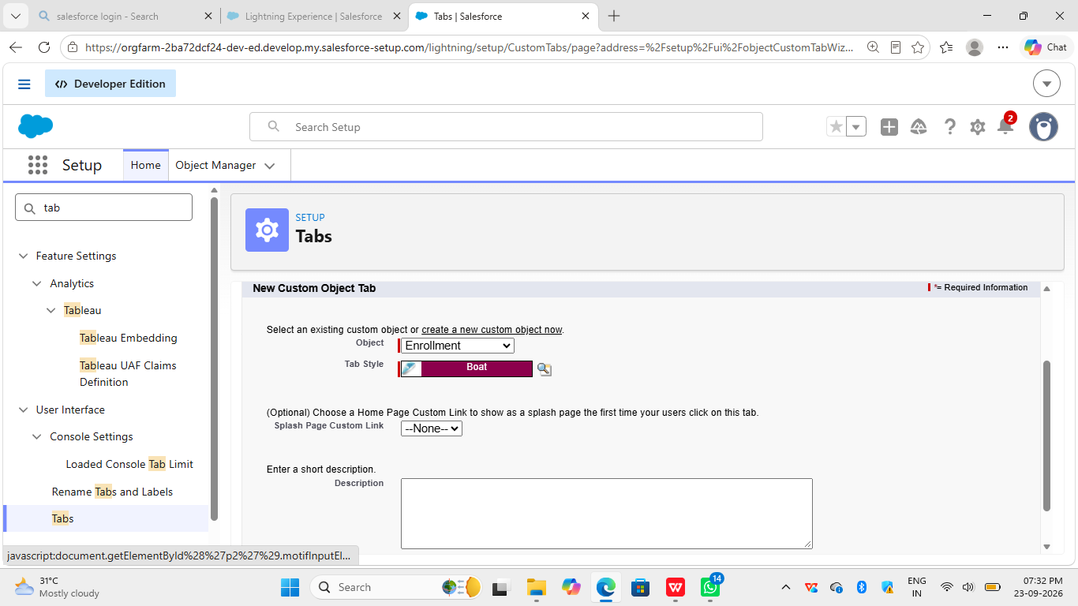

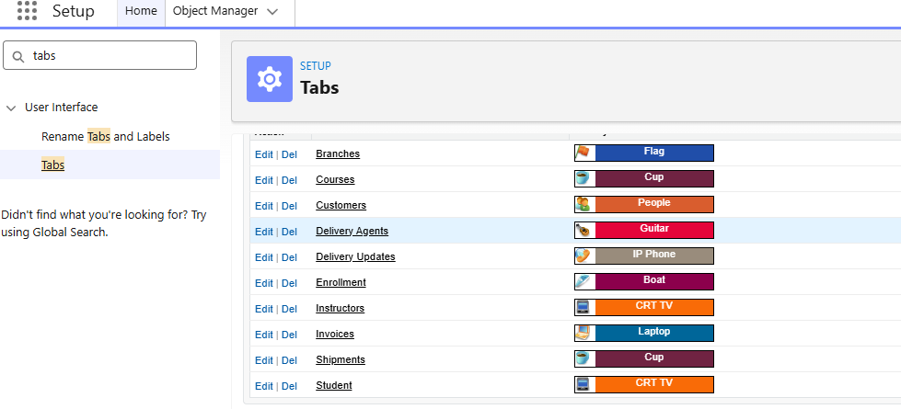

Milestone 8 - Creating Lightning App

1. Go to Setup.
2. Search for App Manager in Quick Find.
3. Click on App Manager.
4. Click New Lightning App (top right).
5. Enter App Name: Student Enrollment & Course Management and click Next.
6. Skip branding, just click Next.
7. Select Standard Navigation and click Next.
8. Select Profiles - Admin, Enrollment Officer, Instructor - and move to right side. Click Next.
9. Select these 8 tabs and add to your app:
- Student
- Course
- Instructor
- Enrollment
- Reports
- Dashboards
- Home
- Tasks
- Click Next, then Save & Finish
.
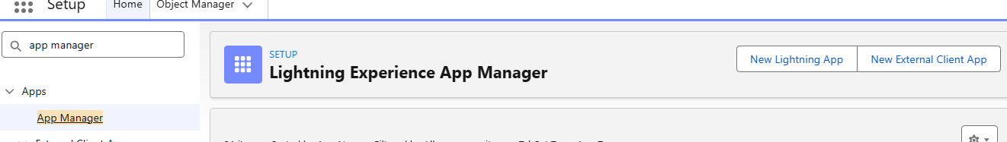

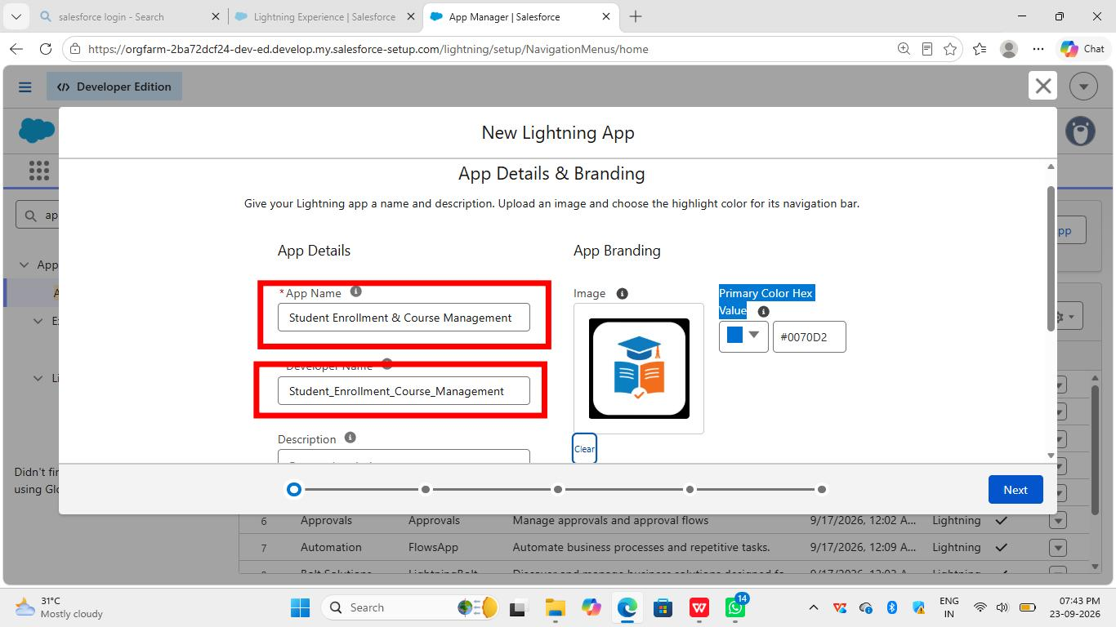

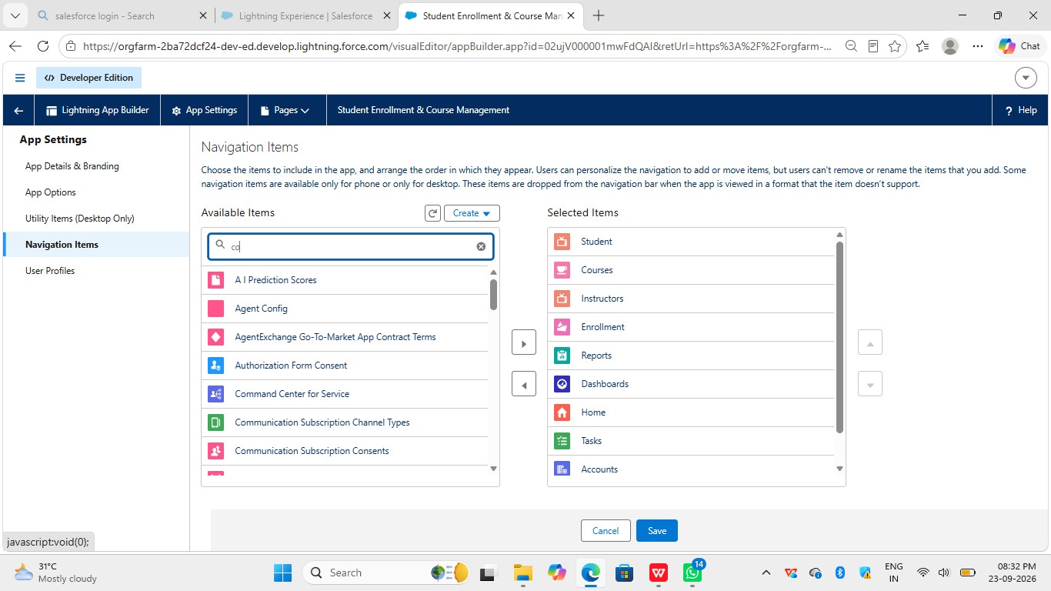

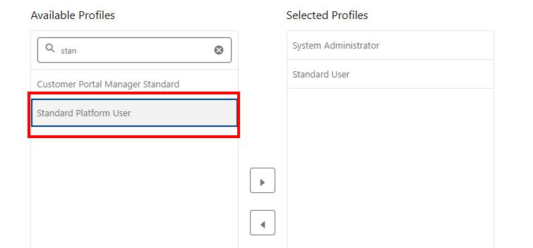

Milestone 9 – Page Layouts and Record:
Activity 1: Create Record Types for Enrollment:

Step 1: Open Enrollment Object
1. Go to Setup
2. Click Object Manager
3. Click on Enrollment

Step 2: Open Record Types
1. Click Record Types on the left side
2. Click New button

Step 3: Create First Type - New Enrollment
1. Existing Record Type: Select Master
2. Record Type Label: Write `New Enrollment`
3. Make it Active
4. Enable for profiles: Check Admin and Enrollment Officer
5. Click Next
6. Select Page Layout and click Save & New

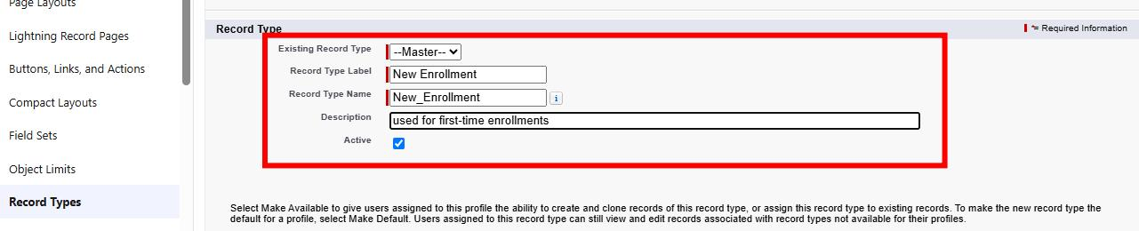
Step 4: Create Second Type - Re-Enrollment
1. Record Type Label:Write `Re-Enrollment`
2. Enable for same profiles: Admin and Enrollment Officer
3. Click Next
4. Select Page Layout and click Save

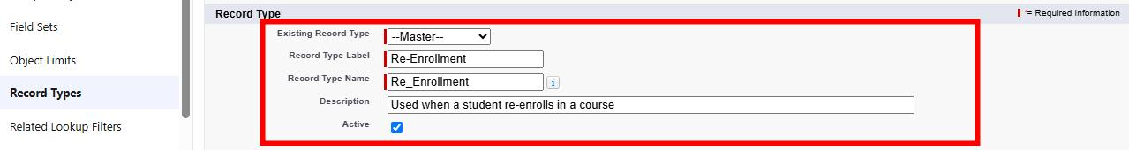

Activity 2: Separate Page Layo Createuts for Each Enrollment Record
Type Purpose:
To show different fields for New Enrollment vs Re-Enrollment.

Step 1:
Go to Enrollment__c -> Page Layouts
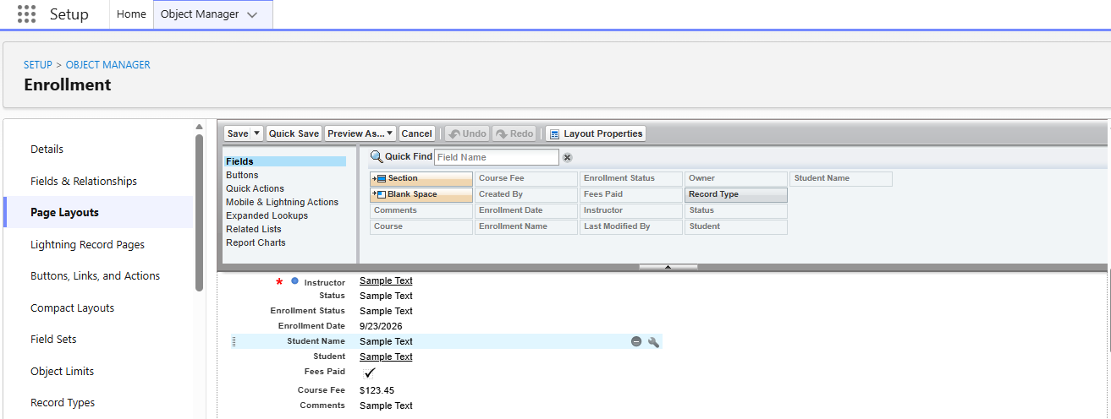

Step 2: New Enrollment Layout
1. Click New
2. Select Enrollment Layout and click Save
3. Change name to New Enrollment Layout
4. Keep fields: Student, Course, Instructor, Enrollment Date, Status, Fees
5. Remove other fields
6. Click Save

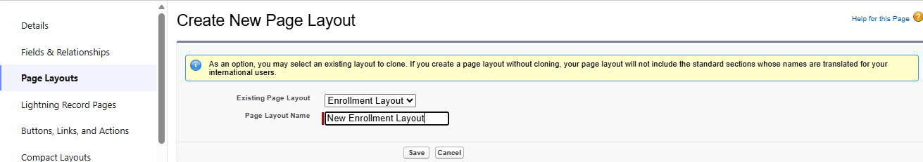

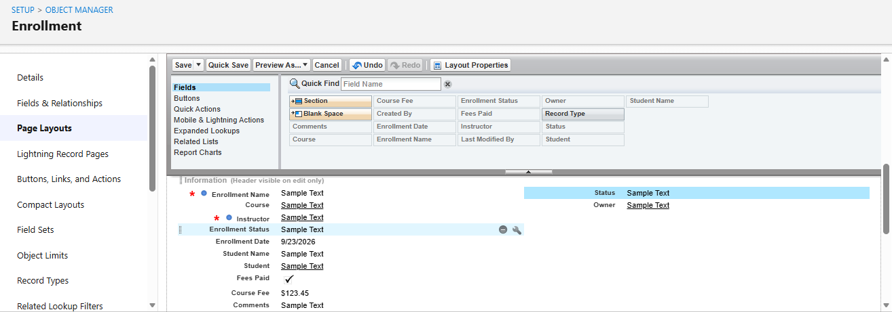
Step 3: Re-Enrollment Layout
1. Again click New
2. Select Enrollment Layoutand click Save
3. Change name to Re-Enrollment Layout
4. Keep fields: Previous Enrollment, Re-Enrollment Reason, Status, Fees
5. Click Save

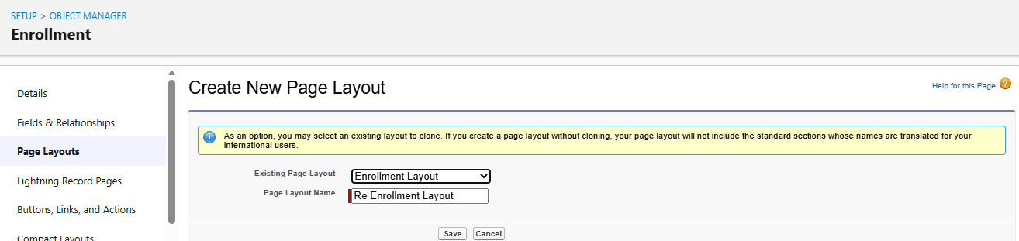

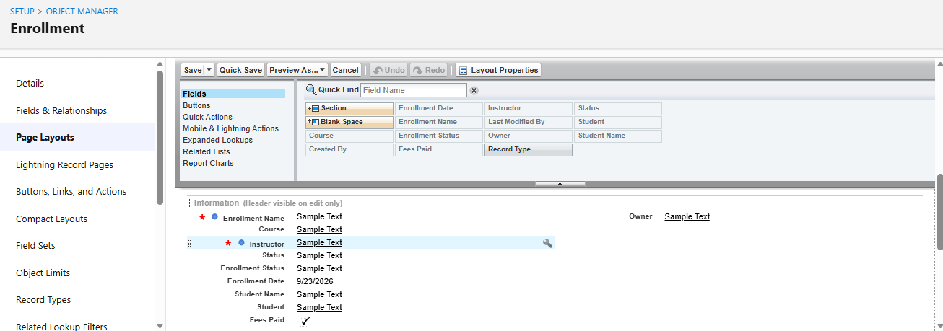

Step 4: Assign
1. Click Page Layout Assignment
2. Click Edit Assignment
3. New Enrollment-> select New Enrollment Layout
4. Re-Enrollment-> select Re-Enrollment Layout
5. Click Save

Activity 3: Enrollment - Add Related Lists to Parent Objects

Purpose:
To see all Enrollments from Student, Course, and Instructor records.

a) Student → Enrollment Related List
- Go to Setup → Object Manager → Student__c.
- Click Page Layouts → open the main layout.
- In the palette, select Related Lists.
- Drag Enrollments related list onto the layout.
- Customize columns if needed → Save.

b) Course → Enrollment Related List
- Go to Object Manager → Course__c → Page Layouts.
- Open layout → add Enrollments related list.
- Save.

c) Instructor → Enrollment Related List
- Go to Object Manager → Instructor__c → Page Layouts.
- Open layout → add Enrollments related list.
- Save.

Milestone 10 – Automation with Flow
Activity 1: Auto-Populate Enrollment Date (Record-Triggered Flow)

Purpose:
When a new Enrollment is created, the Enrollment Date should be set to today's date automatically.

Steps:

1. Go to Setup → Flows → New Flow.
2. Select Record-Triggered Flow → Click Create.
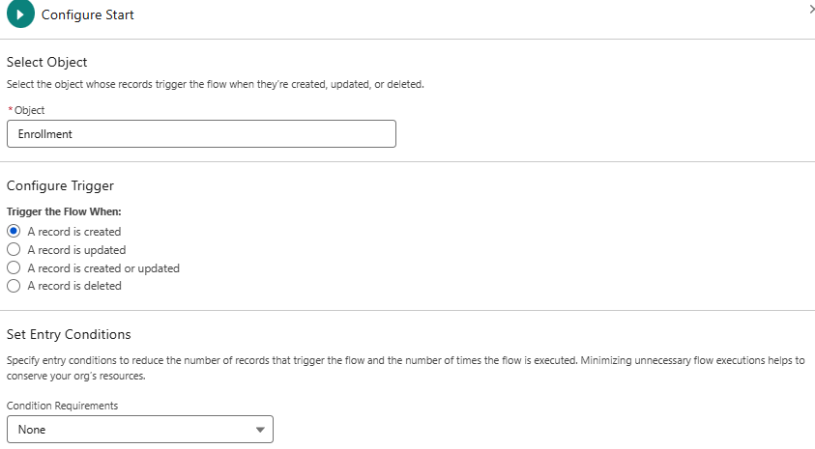

3. Select Object: Enrollment__c
4. Trigger: A record is created.
5. Select Optimize for Actions and Related Records → Click Done.
6. Add an Update Records element:
- Label: Set Enrollment Date
- Select Use the record that triggered the flow
- Set Field: Enrollment_Date__c → Value: $Flow.CurrentDat
e
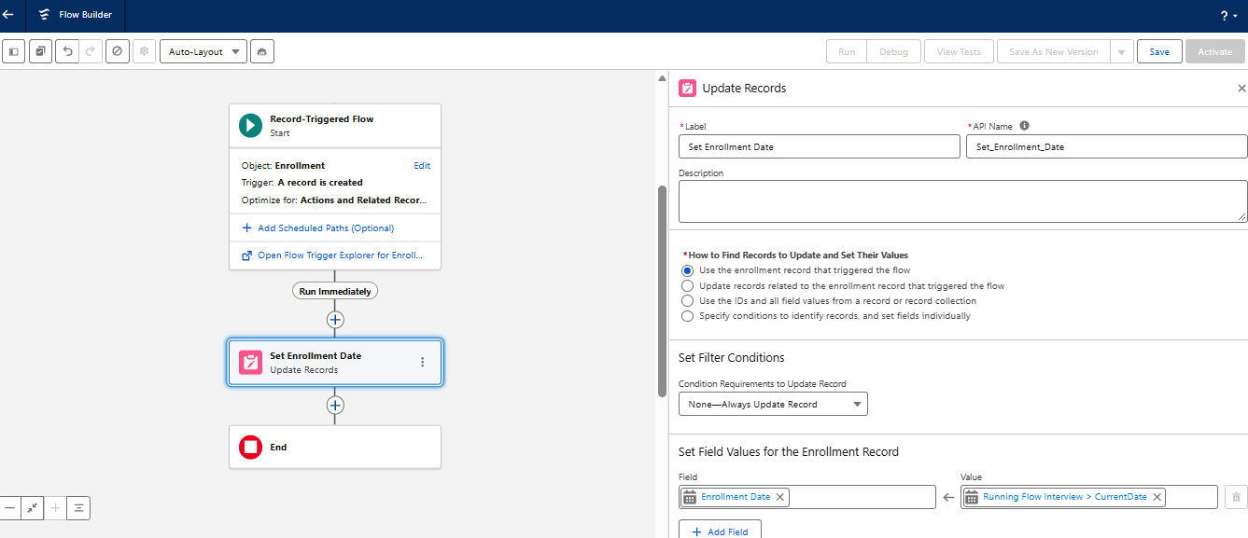

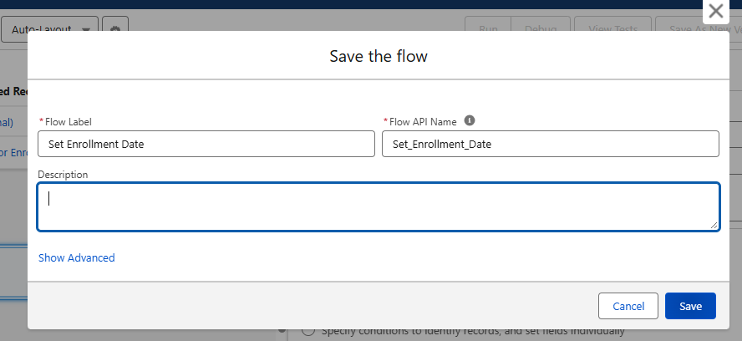

7.Save as SetEnrollmentDate → Activate.
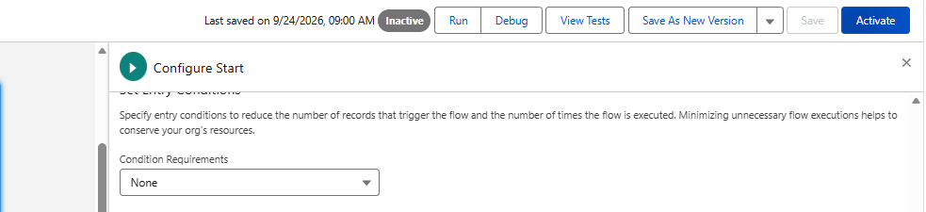
Activity 2: Send Email When Enrollment Approved

Purpose:
When Enrollment Status becomes Approved, send an email to the student, alert the admin, and make the Student Active.

Steps:

1. Create an Email Template and an Email Alert for the student.
2. Go to Flows → New → Record-Triggered Flow.
3. Select Object: Enrollment__c, Trigger: A record is updated.
4. Set Condition: Enrollment_Status__c Equals "Approved".
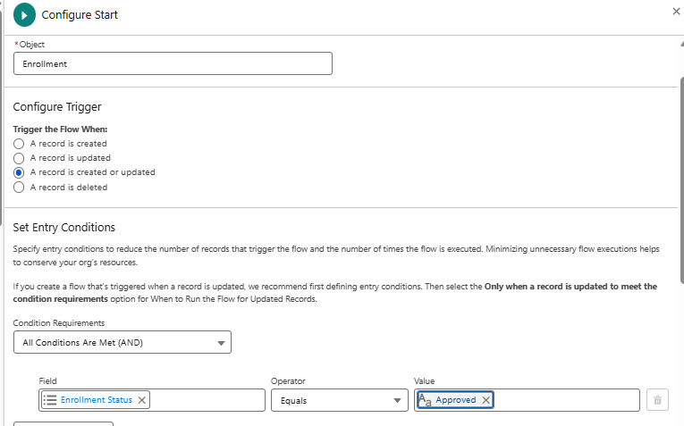
5. Add Get Records to fetch the related Student__c.
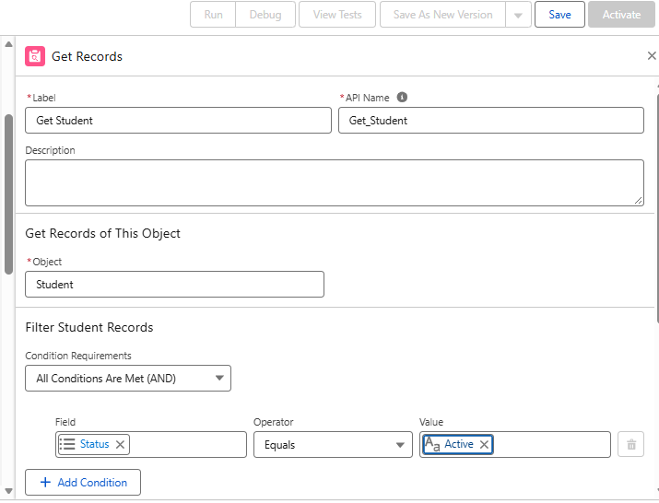
6. Add an Action (Email Alert)to send email to the student.

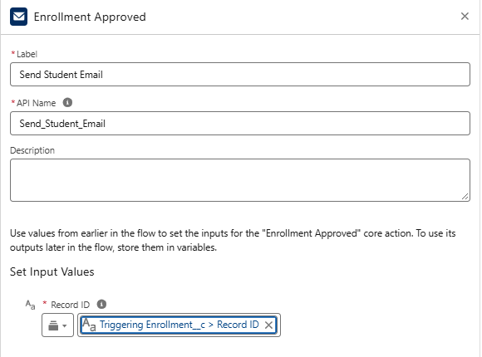

7. Add an Action to notify the Admin if needed.
8. Add Update Records to set Student c.Status c = "Active".
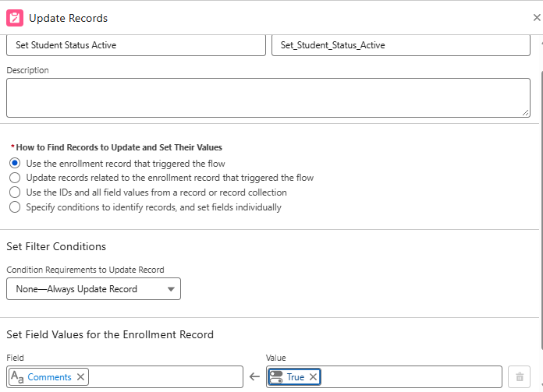
9. Save as Enrollment Approved Action→ Activate.

Activity 3: Auto-Assign Instructor Based on Course Category

Purpose:
Assign Instructor automatically based on Course category.
Rules:
Technical → Instructor A
Language → Instructor B
Non-Technical → Instructor C

Steps:

1. Prepare Instructor__c records with codes (e.g., INSTR_A, INSTR_B,
INSTR_C).
2. Create Record-Triggered Flow on Enrollment__c (created/updated).
3. Add Get Records to fetch related Course__c.
4. Add Decision element on Course__r.Category__c:
5. Technical / Language / Non-Technical outcomes.
6. For each outcome:
7. Get Instructor record (A/B/C) based on code or name.
8. Update Records: set Instructor__c = Get_Instructor_X.Id.
9. Save as AutoAssign_Instructor → Activate.

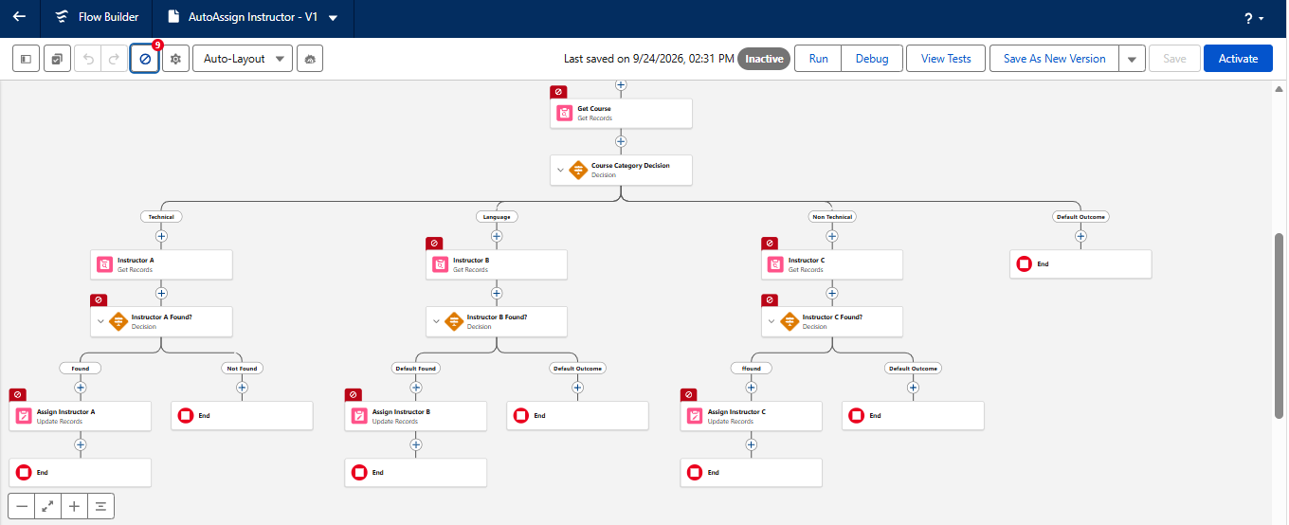

Activity 4: Auto-Create Task for Follow-Up

Purpose:
When Enrollment is “Requested”, create a follow-up task for Admin.

Step 1: Create Record-Triggered Flow
- Go to Salesforce → Setup
- Search Flows in Quick Find.
- Open Flows → click New Flow.
- Select Record-Triggered Flow.
- Click Create.
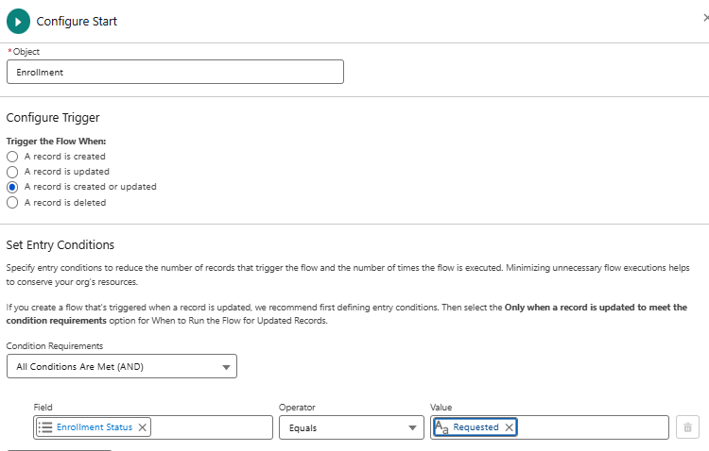

Step 3: Fetch Admin User
- Add a Get Records element to the Flow.
- Select the User object.
- Set the condition to find the Admin User using Username or Profile.
- Select Only the first record to store the Admin user details.
- Save the element as Get Admin User.

step 4: Create Due Date Formula
- Go to Manager in the Flow Builder.
- Click New Resource.
- Select Formula as the Resource Type.
- Set the Data Type to Date.
- Enter the formula:
TODAY() + 2
- Save it as Due Date.
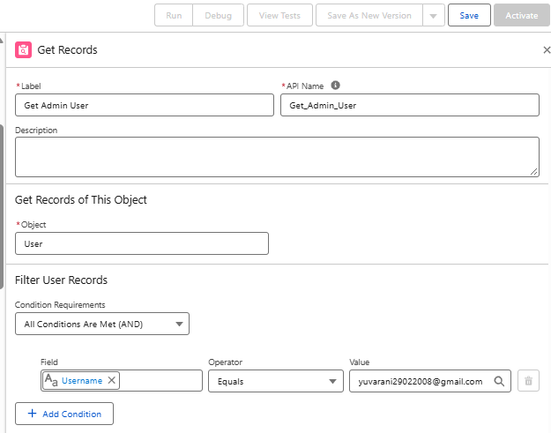
5
. Add Create Records for Task:
6. Subject: Follow up on enrollment request.
7. OwnerId: Admin user Id.
8. WhatId: Enrollment Id.
9. ActivityDate: formula Today + 2.
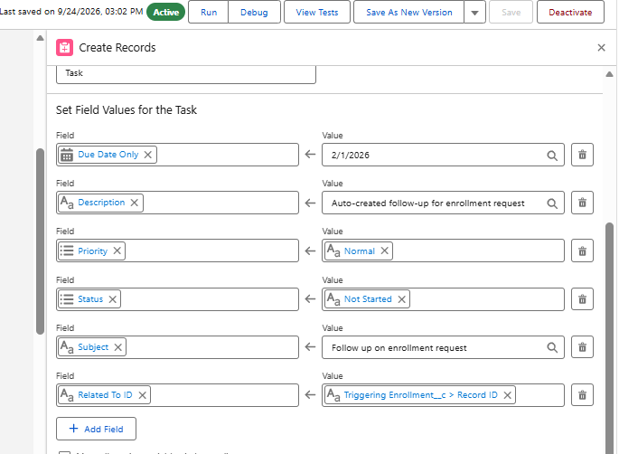

10.Save as Create_Followup_Task → Activate.

Milestone 11 – Reports:
Activity 1: Create “Students by Status” Report

1.Go to Reports → New Report.
2.Report Type: Students.
3.Group rows by Status__c.
4.Add columns as needed (Name, Email, Phone).
5.Save as Students by Status.
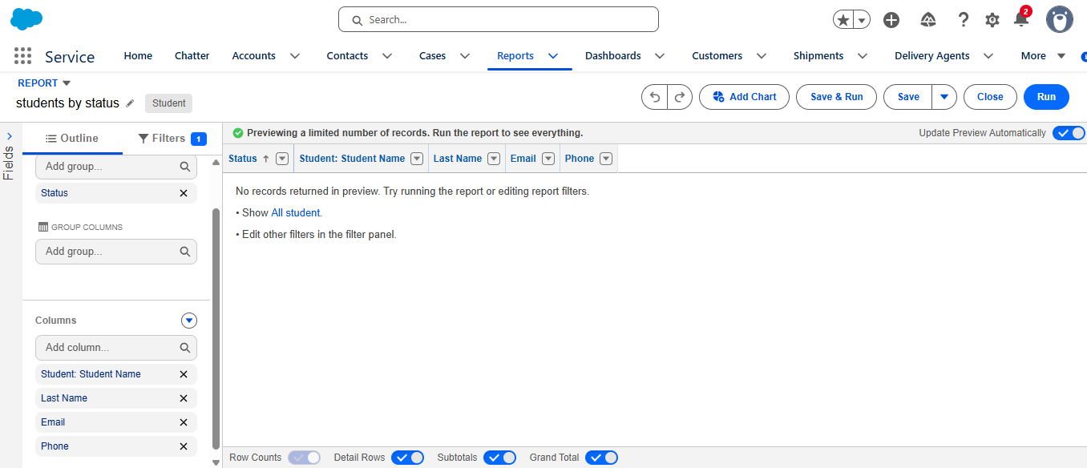
Activity 2: Create “Enrollments by Course” Report

1.New Report → Report Type: Enrollments.
2.Grouprows by Course__r.Name.
3.Show Record Count per course.
4.Save as Enrollments by Course

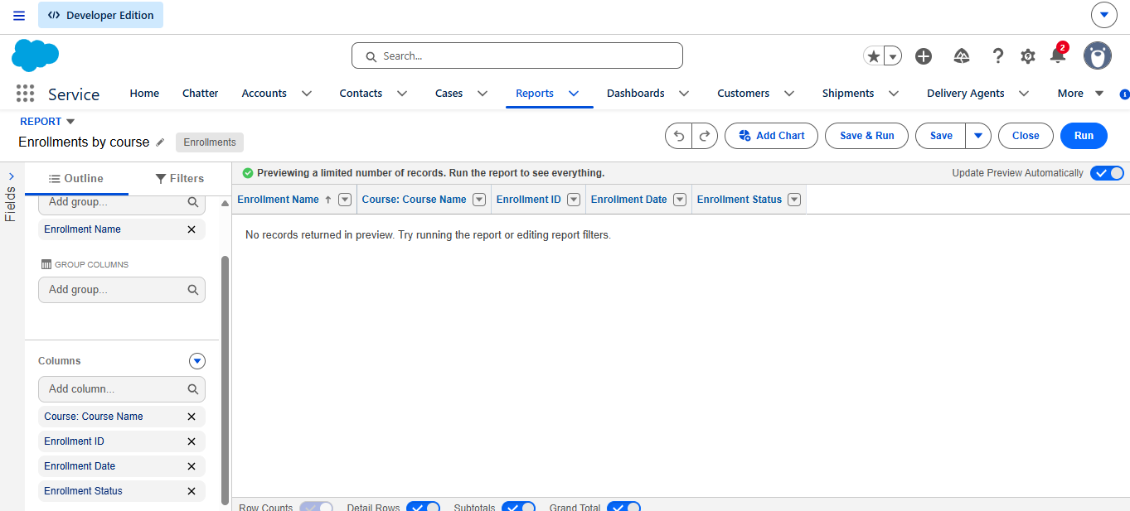

Activity 3: Create “Pending Enrollment Approvals” Report

1.New Report → Enrollments report type.
2.Filter: Enrollment_Status__c = "Requested".
3.Add columns (Student, Course, Owner, Created Date).
4.Save as Pending Enrollment Approvals.

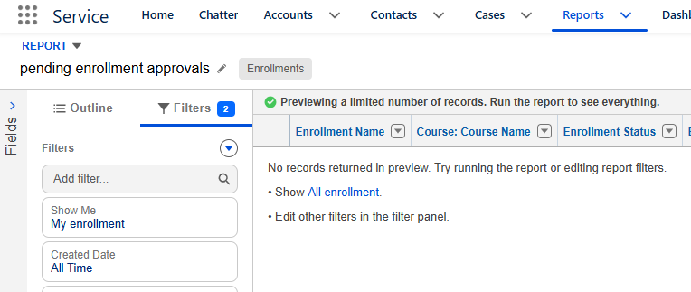

Activity 4: Create “Revenue Report (Fees Paid)” Report

1.New Report → Enrollments report type.
2.Filter: Fees_Paid__c = TRUE.
3.Group by Course__r.Name.
4.Summarize Course_Fee__c or similar fee field.
5.Save as Revenue Report – Fees Paid.

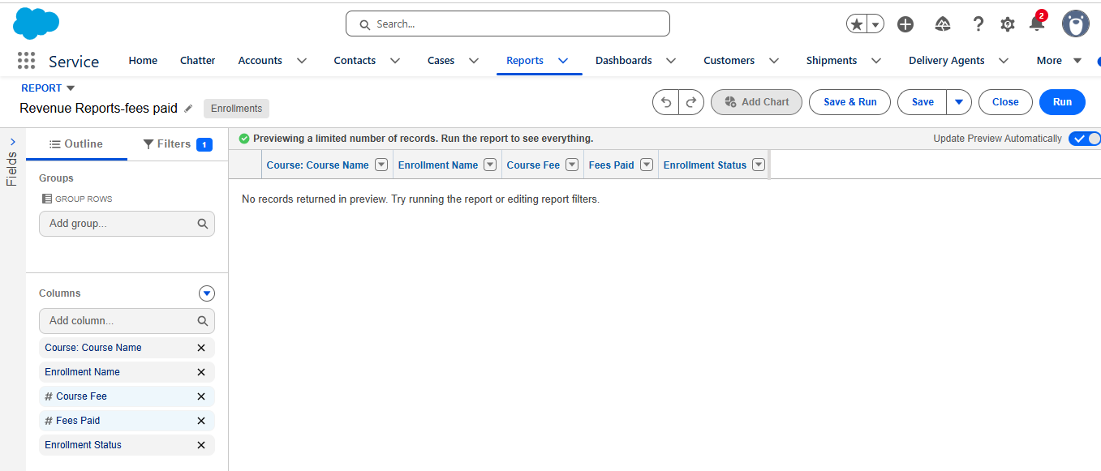

Milestone 12 – Dashboards:

Activity 1: Create “Student Managemet Dnashboard”

Steps:
1.Go to Dashboards → New Dashboard.
2.Name: Student Management Dashboard.
3.Select folder → Create.
4.Select new Dashboard folder and Save.
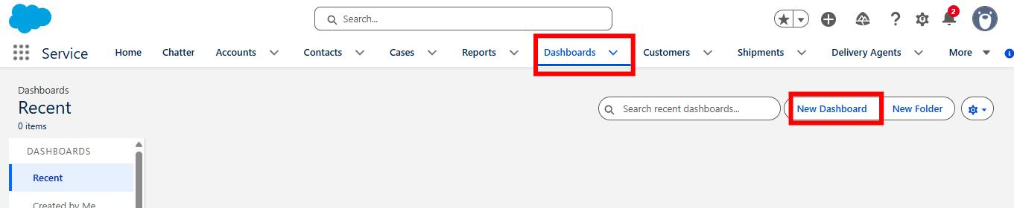

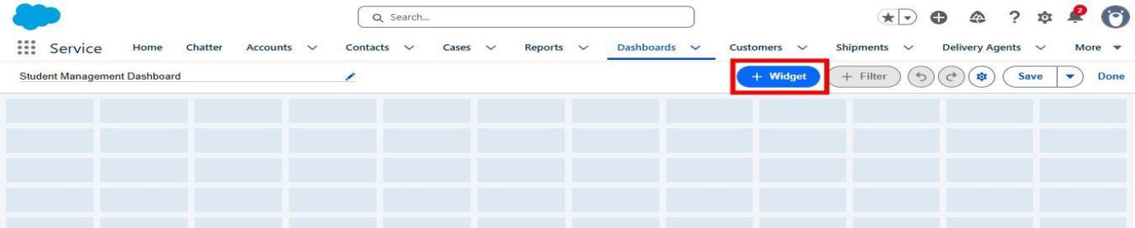
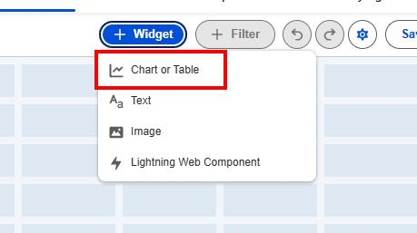

Add components:
● Donut Chart → using Students by Status report.
● Bar Chart → using Enrollments by Course report.
● Gauge → using Revenue Report – Fees Paid (sum of
revenue field).
● Table → using Pending Enrollment Approvals report.

- Arrange components on canvas.
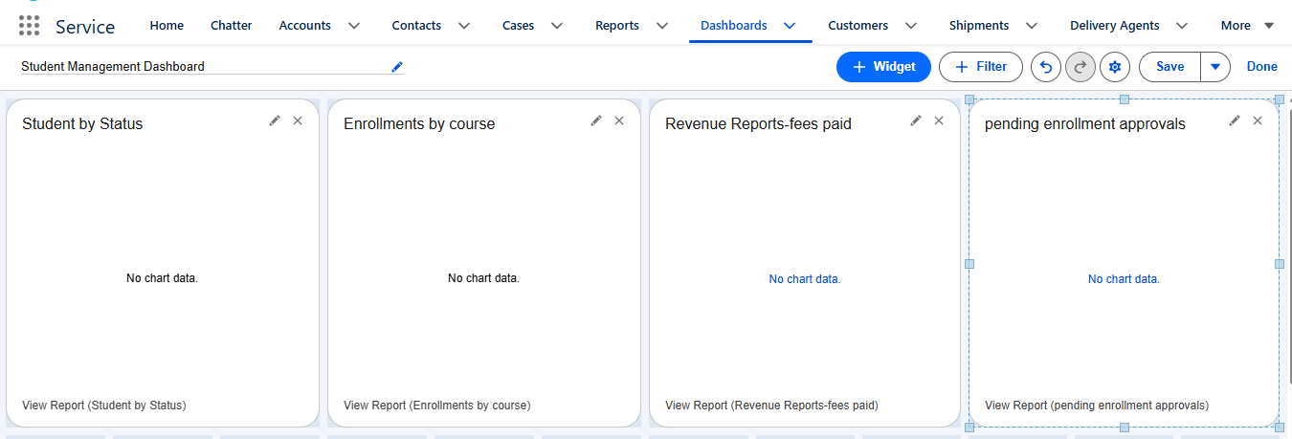
- Click Save → Done.

Milestone 13 – Security Setup

Activity 1: Configure Profiles

Step 1: Create Enrollment Officer Profile
- Go to Salesforce → Setup.
- Search for Profiles in Quick Find.
- Open Profiles.
- Click New Profile or Clone Profile.
- Enter the Profile Name as Enrollment Officer.
- In Object Settings, configure the following permissions:
  - Enrollment__c: Read, Create, Edit.
  - Student__c: Read.
  - Course__c: Read.
- Click Save.

Step 2: Configure Instructor Profile
- Go to Setup → Profiles.
- Create a new profile or clone an existing profile.
- Enter the Profile Name as Instructor.
- In Object Settings, select Enrollment__c.
- Give Read permission only.
- Configure access to assigned Enrollment records as required.
- Click Save.

Step 3: Configure Admin Profile
- Go to Setup → Profiles.
- Select or create the Admin profile.
- Provide Full Access to the required project objects.
- Ensure the Admin can create, read, edit, and manage the required records.
- Click Save.

Activity 2: Create Permission Sets

Step 1: Create Permission Set
- Go to Setup → Permission Sets.
- Click New.
- Enter a suitable Label.
- Configure additional access to the required custom objects.
- Click Save.

Step 2: Create Dashboard Editor Permission Set
- Go to Setup → Permission Sets.
- Click New.
- Enter the Label as Dashboard Editor.
- Provide permissions required to Create and Customize Reports and Dashboards.
- Click Save.
- Assign the Permission Set to the relevant users.

Activity 3: Configure Sharing & OWD

Step 1: Open Sharing Settings
- Go to Salesforce → Setup.
- Search for Sharing Settings in Quick Find.
- Open Sharing Settings.

Step 2: Configure Organization-Wide Defaults
Set the following Organization-Wide Default (OWD) settings

7. FUNCTIONAL & PERFORMANCE TESTING
During the testing phase, screenshots were captured from the Salesforce user interface to verify that all implemented features of the Student Enrollment & Course Management System (SECMS) were working correctly.
The following features were tested:
- Student, Course, Instructor, and Enrollment record creation.
- Validation rules for mandatory fields and enrollment eligibility.
- Validation of enrollment constraints and seat availability.
- Record Type behavior for different course categories.
- Flow execution for automated enrollment approval and seat availability checks.
- Apex Trigger functionality for automatic confirmation and record updates.
- Reports and Dashboards for enrollment tracking, data visualization, and performance monitoring.
Testing Evidence:
Screenshots of the Salesforce interface during testing are submitted as evidence of successful feature execution.

8. ADVANTAGES & DISADVANTAGES

Advantages
- Centralized Data: All student, course, instructor, and enrollment information is maintained in one system.
- Automated Workflows: Flows and automation reduce manual work and improve process efficiency.
- Real-Time Reporting: Reports and dashboards provide updated information for monitoring and decision-making.

Disadvantages
- Salesforce Dependency: The system depends on the Salesforce platform for its operation.
- Initial Configuration Effort: Setting up objects, security, automation, and reports requires initial time and effort.

9. CONCLUSION
The Salesforce Student Enrollment & Course Management System (SECMS) successfully manages the student academic process from student registration and course creation to enrollment management, instructor assignment, approval, and reporting.By using Salesforce features such as Validation Rules, Flows, Approval Processes, Apex Triggers, Reports, and Dashboards, the system helps improve data accuracy, reduce manual work, and support efficient academic management.This project demonstrates how Salesforce can be used to transform traditional manual enrollment processes into a reliable, organized, and user-friendly digital system.

10. FUTURE SCOPE
The system can be enhanced in the future by adding the following features:
- Payment Gateway Integration for online fee payments.
- Student Self-Service Portal for students to manage their enrollments and course information.
- Analytics-Driven Insights for advanced analysis of student and enrollment data.
- Mobile Access Support to allow users to access the system through mobile devices.

11. APPENDIX
The following resources are included as part of the project:
- Source Code: Salesforce Configuration, Flows, Validation Rules, and Apex Components.
- Dataset: Salesforce Objects and Records used in the project.
- GitHub / Demo: Salesforce Developer Org and project demonstration details.

Thank You😊

